Automating CI/CD Pipeline for Spring Boot Application Deployment on AWS

Description
Objective
To implement a CI/CD pipeline using AWS services for automating the deployment of a Spring Boot application on Amazon ECS with Docker, integrating CodePipeline, CodeBuild and ECR for seamless updates
Problem Statement and Motivation
Real-time scenario:
magine a retail company that has a Spring Boot-based inventory management system. The system is used by several departments and is hosted in containers to ensure scalability. The company wants to reduce the manual intervention required to deploy updates by automating the build and deployment process. By setting up a CI/CD pipeline, developers can push updates to a GitHub repository, automatically triggering a sequence of actions that build, containerize, and deploy the application without downtime. This ensures faster and more reliable system updates, minimizing operational delays.

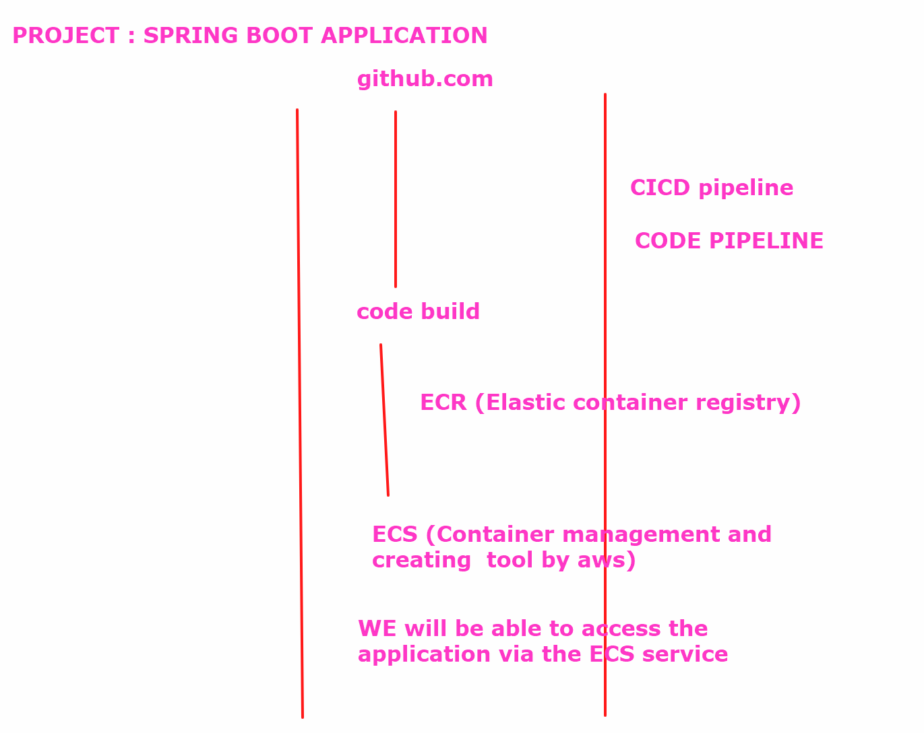
We will create a cicd pipeline via code pipeline where we will deploy a springboot application on ECS docker containers ….

Your code would be picked up -> it will go to code build where the project will be converted to the war file (single executable file) -> we execute the dockerfile to create custom image which would be pushed to ecr -> from there it would be picked by ecs task to deploy the project

Fork the repo https://github.com/akshu20791/aws-devops-springbootapp

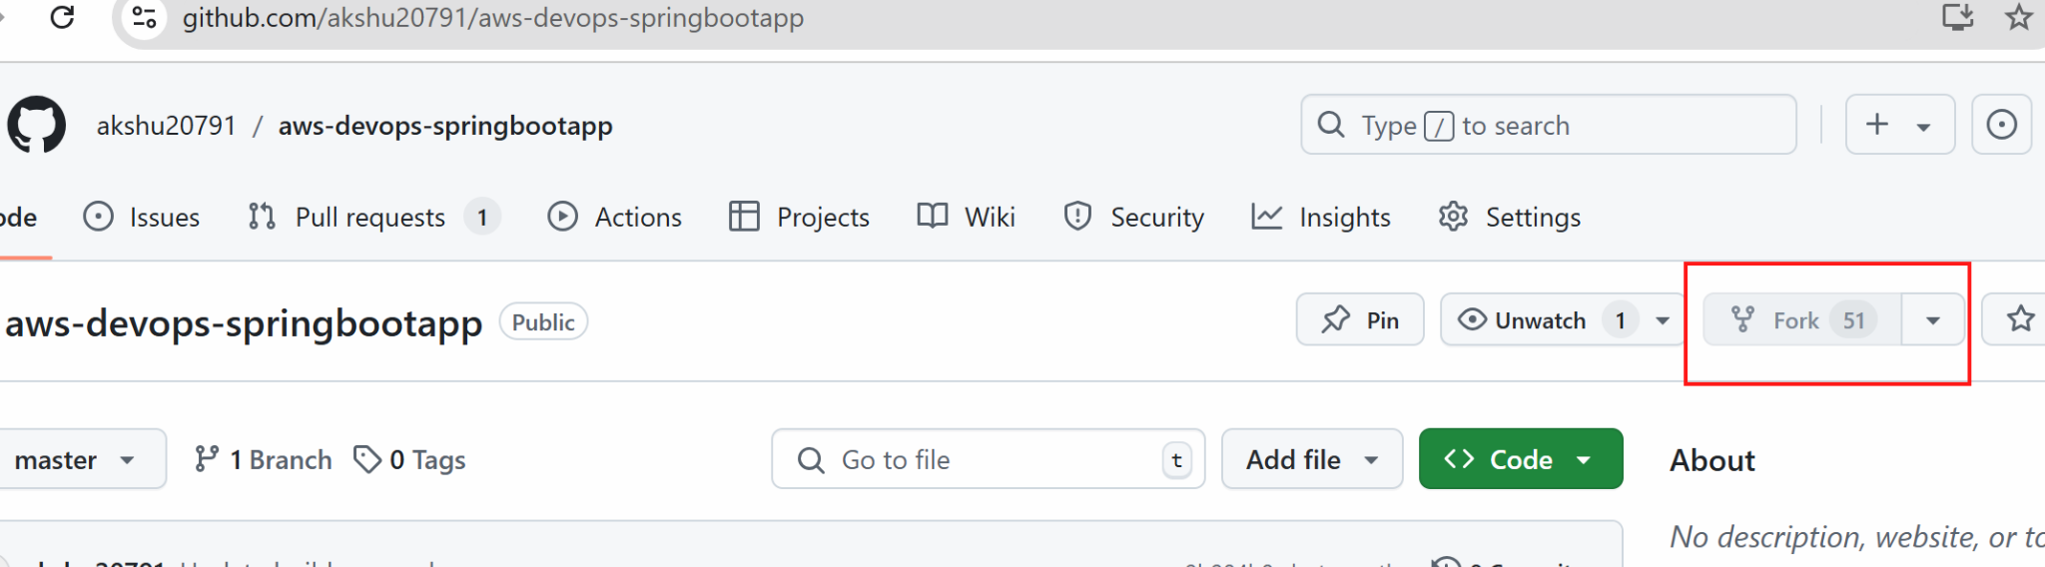

- We will create a ecr :
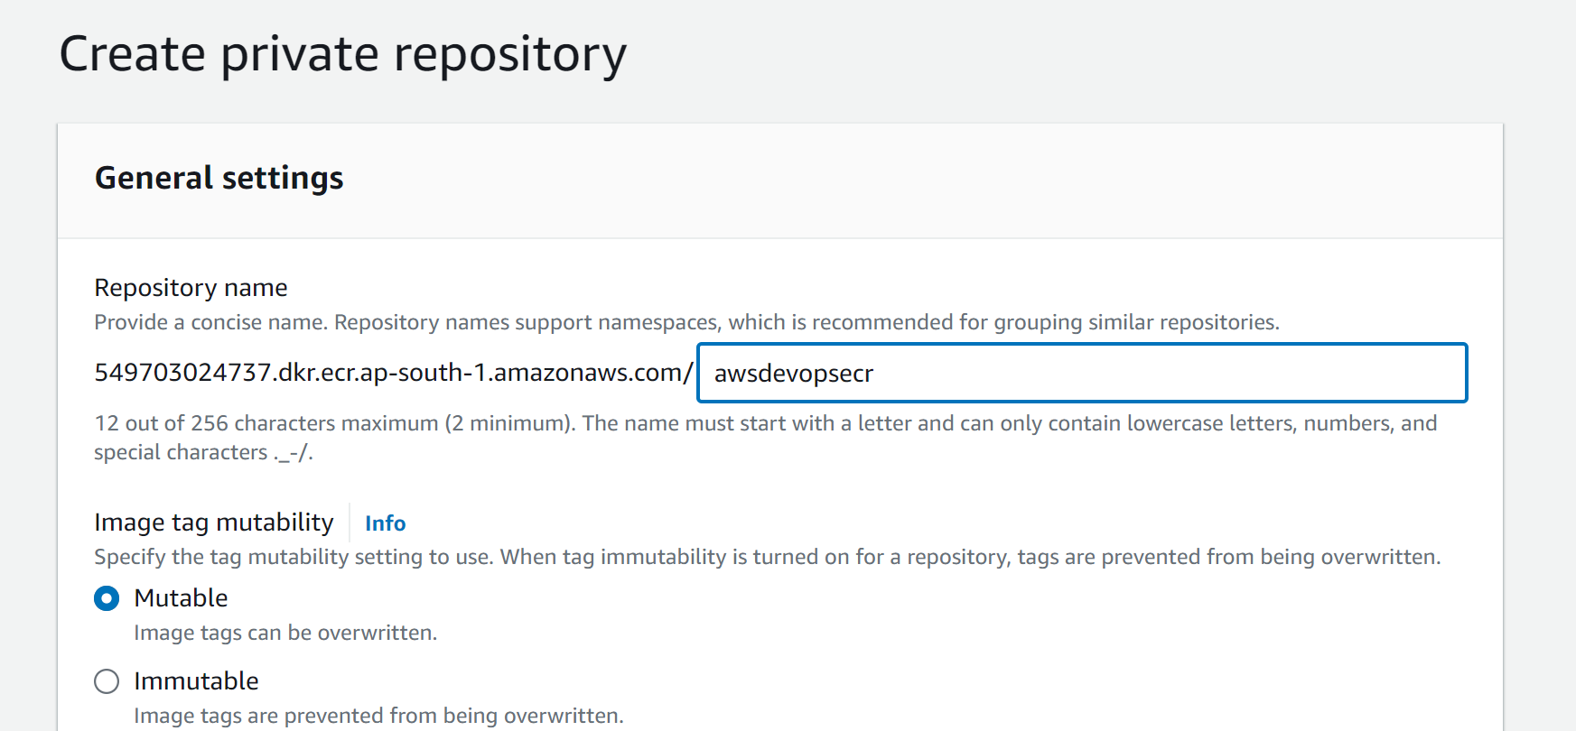

Create

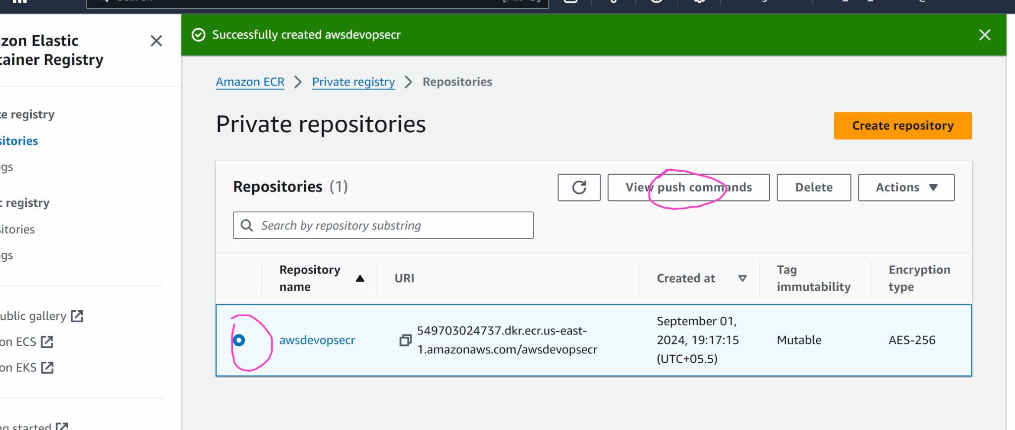

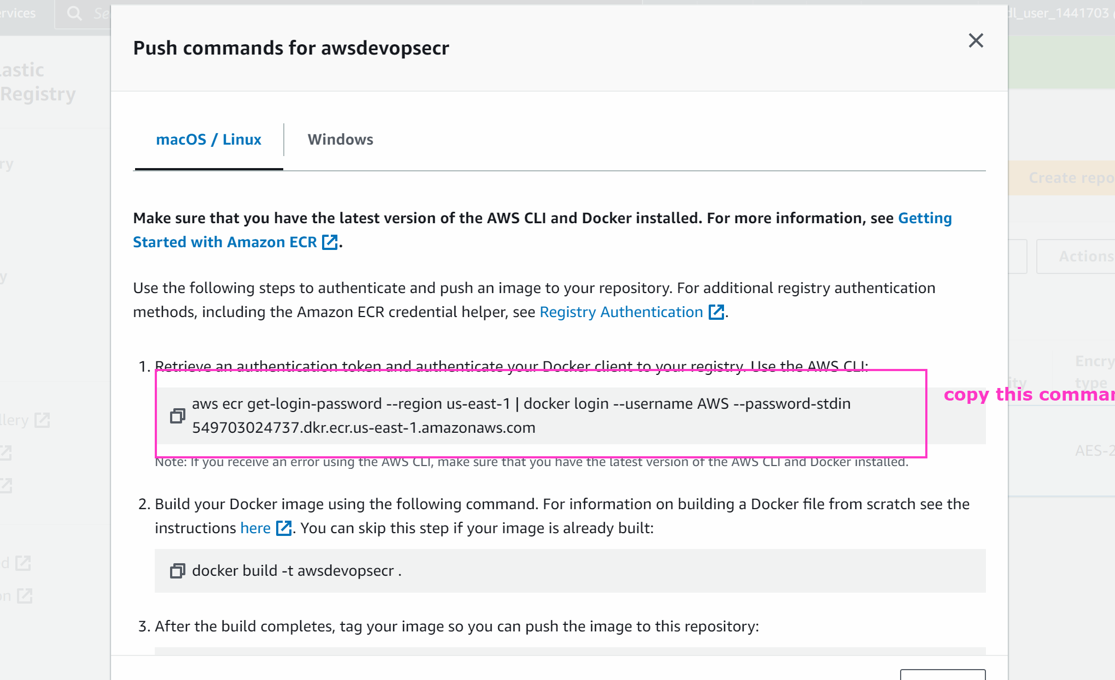

- Go to github repo

Click on buildspec.yml -> edit the file (by clicking in pencil icon)

Update line no 10 with the code you copied in step 2
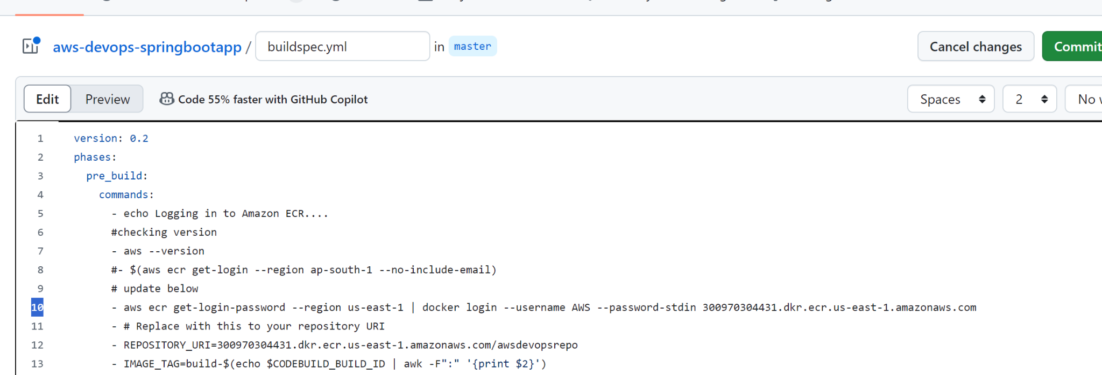
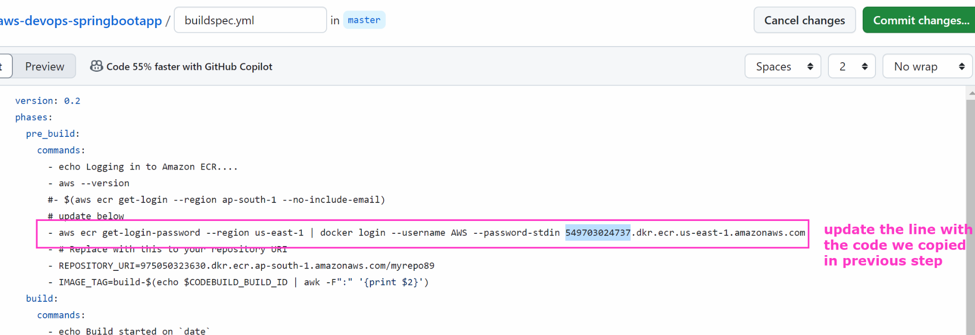

- GO BACK TO AWS -> ECR -> Copy the ecr image uri
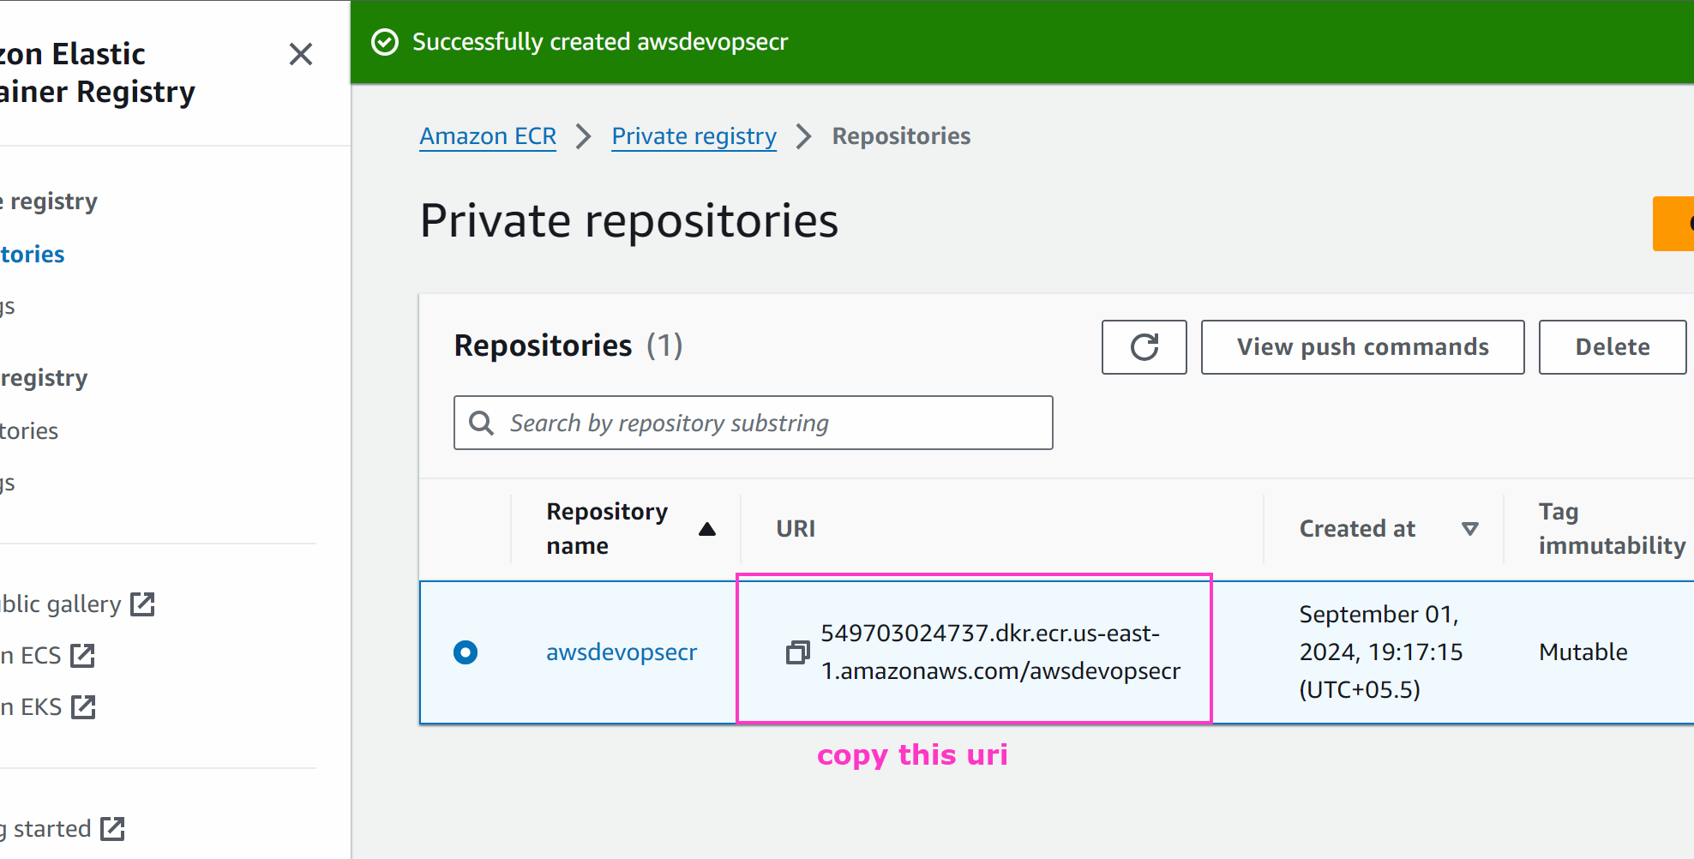

- Paste in buildspec.yml file in your github account
On line 12 of buildspec.yml file paste the
REPOSITORY_URI=<PASTE THE URL which u copied in step 3>
(on line 12)
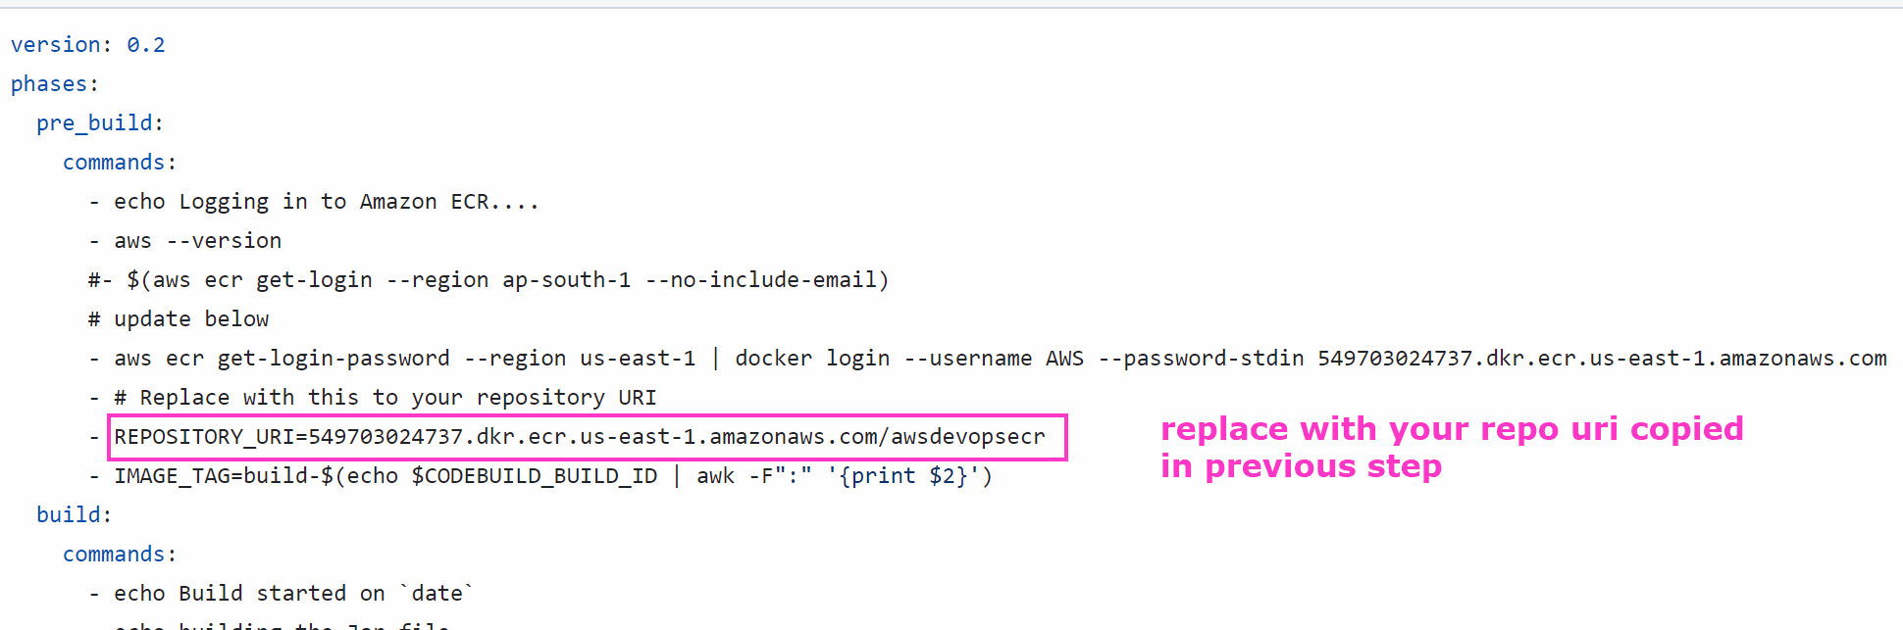
IT SHOULD LOOK LIKE THIS:

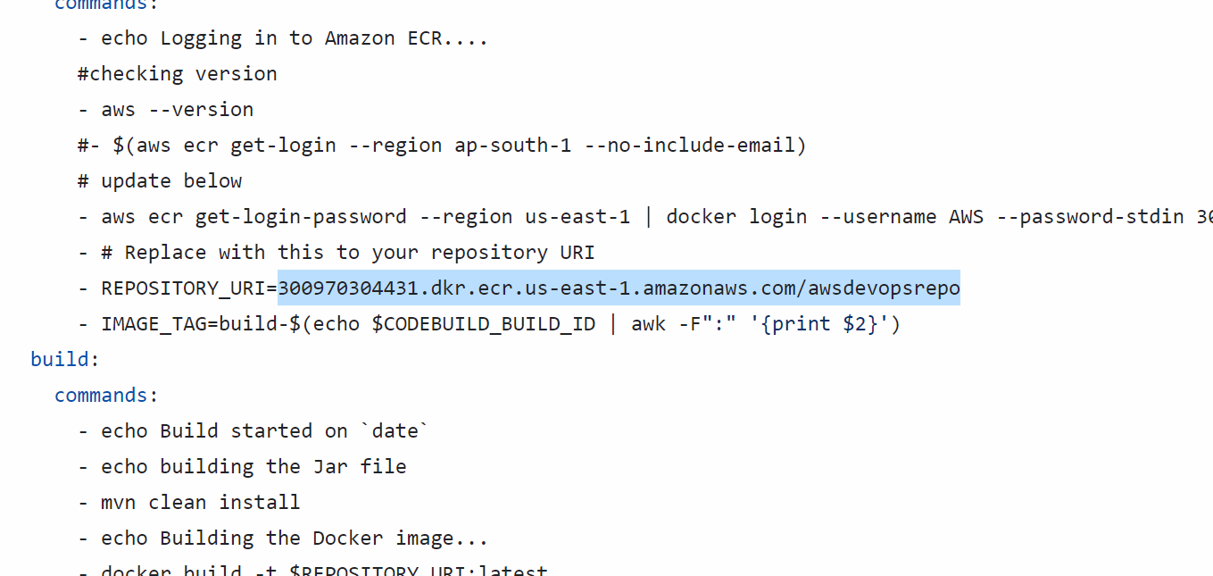

Commit the changes
- Now we will go to code build and create a code build project
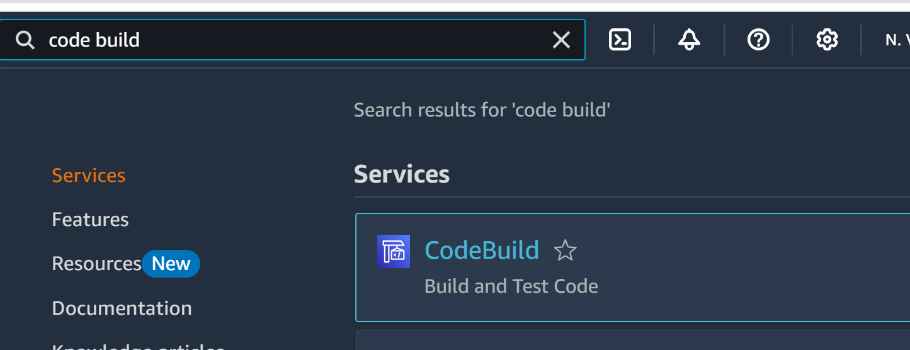
Create project

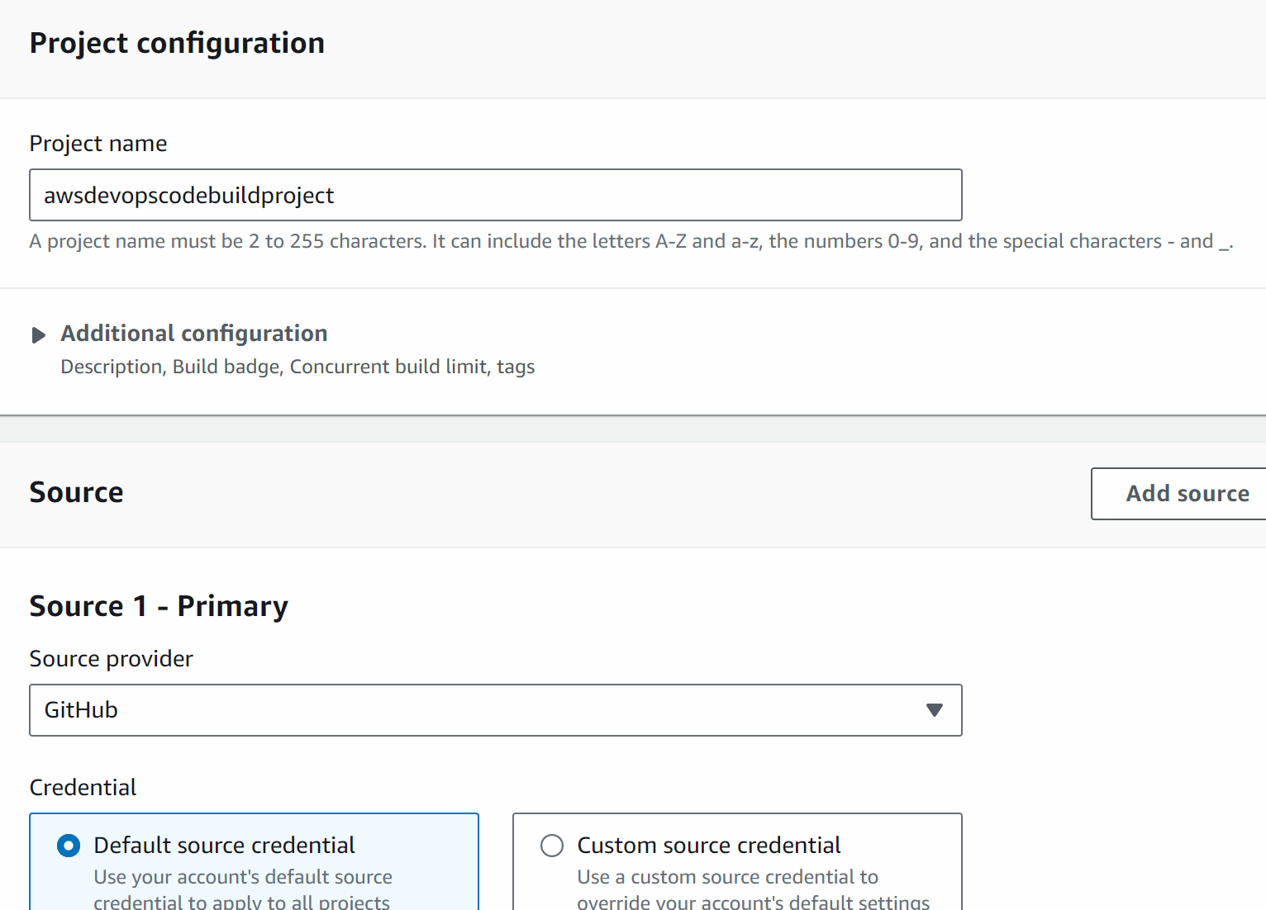

Click on manage default source credentials

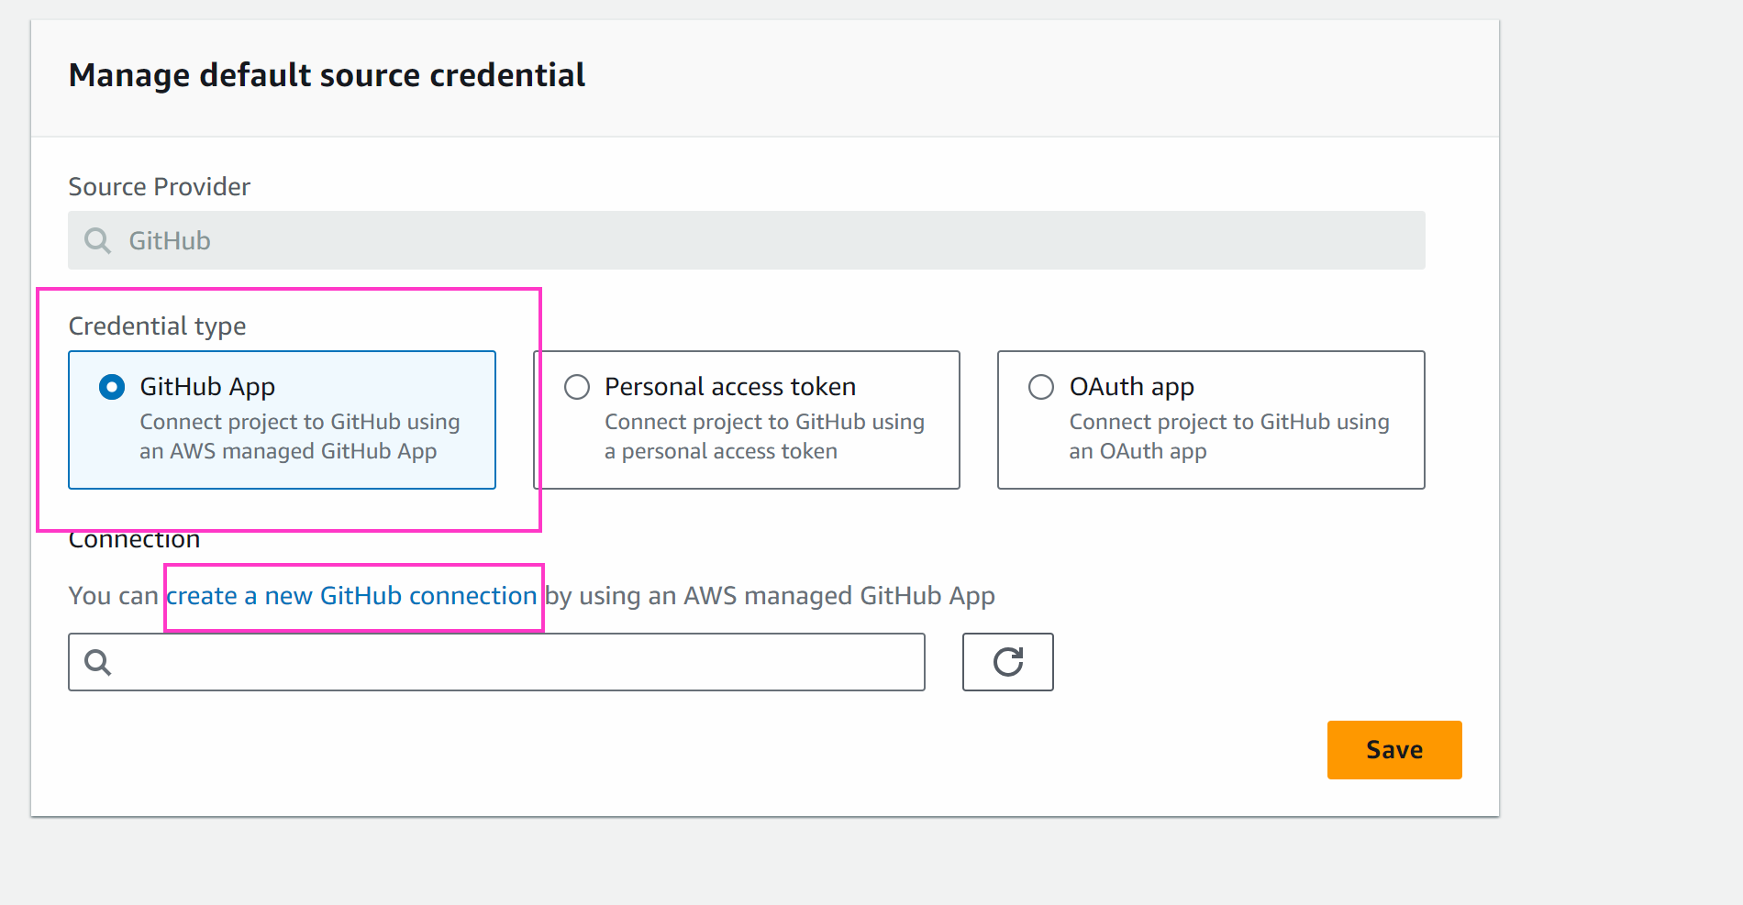

A pop up will open

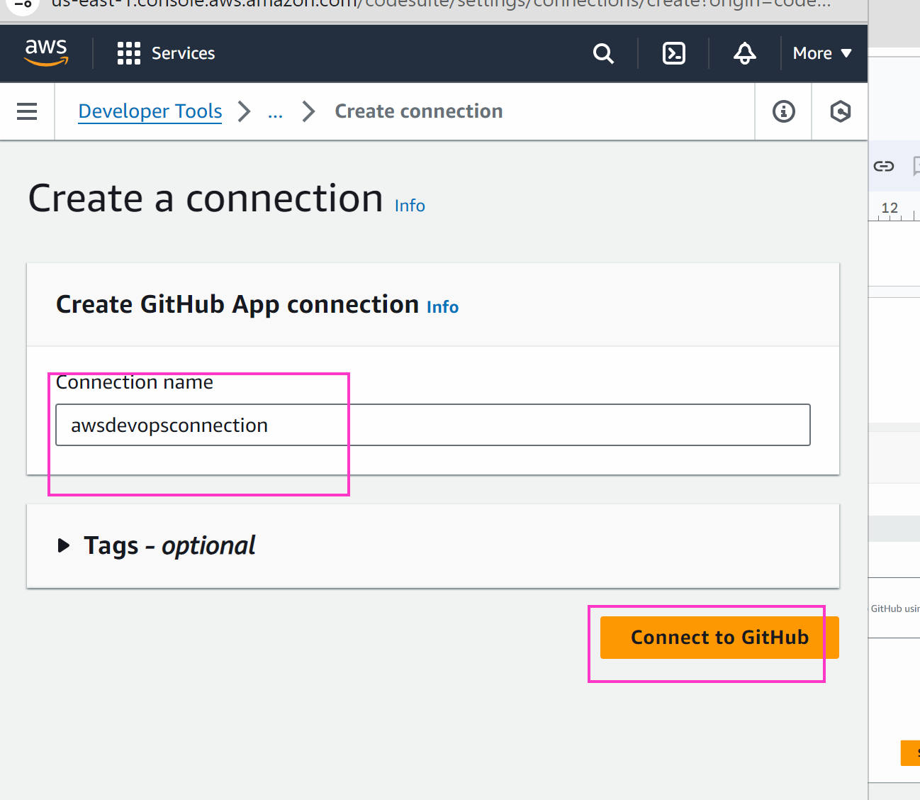

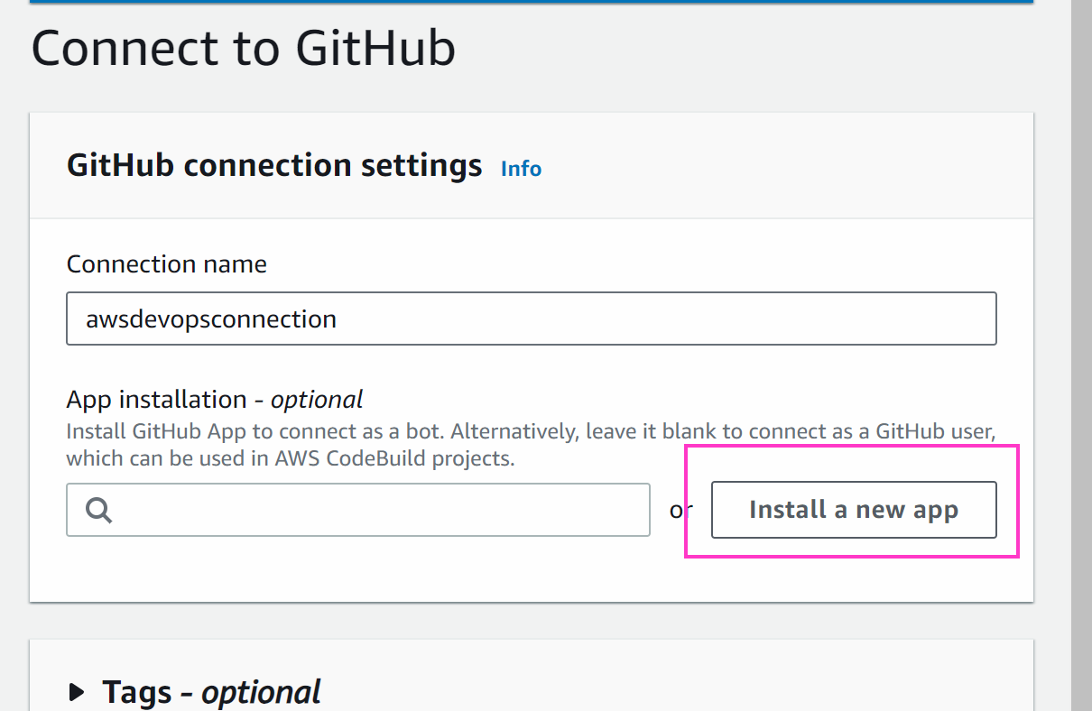

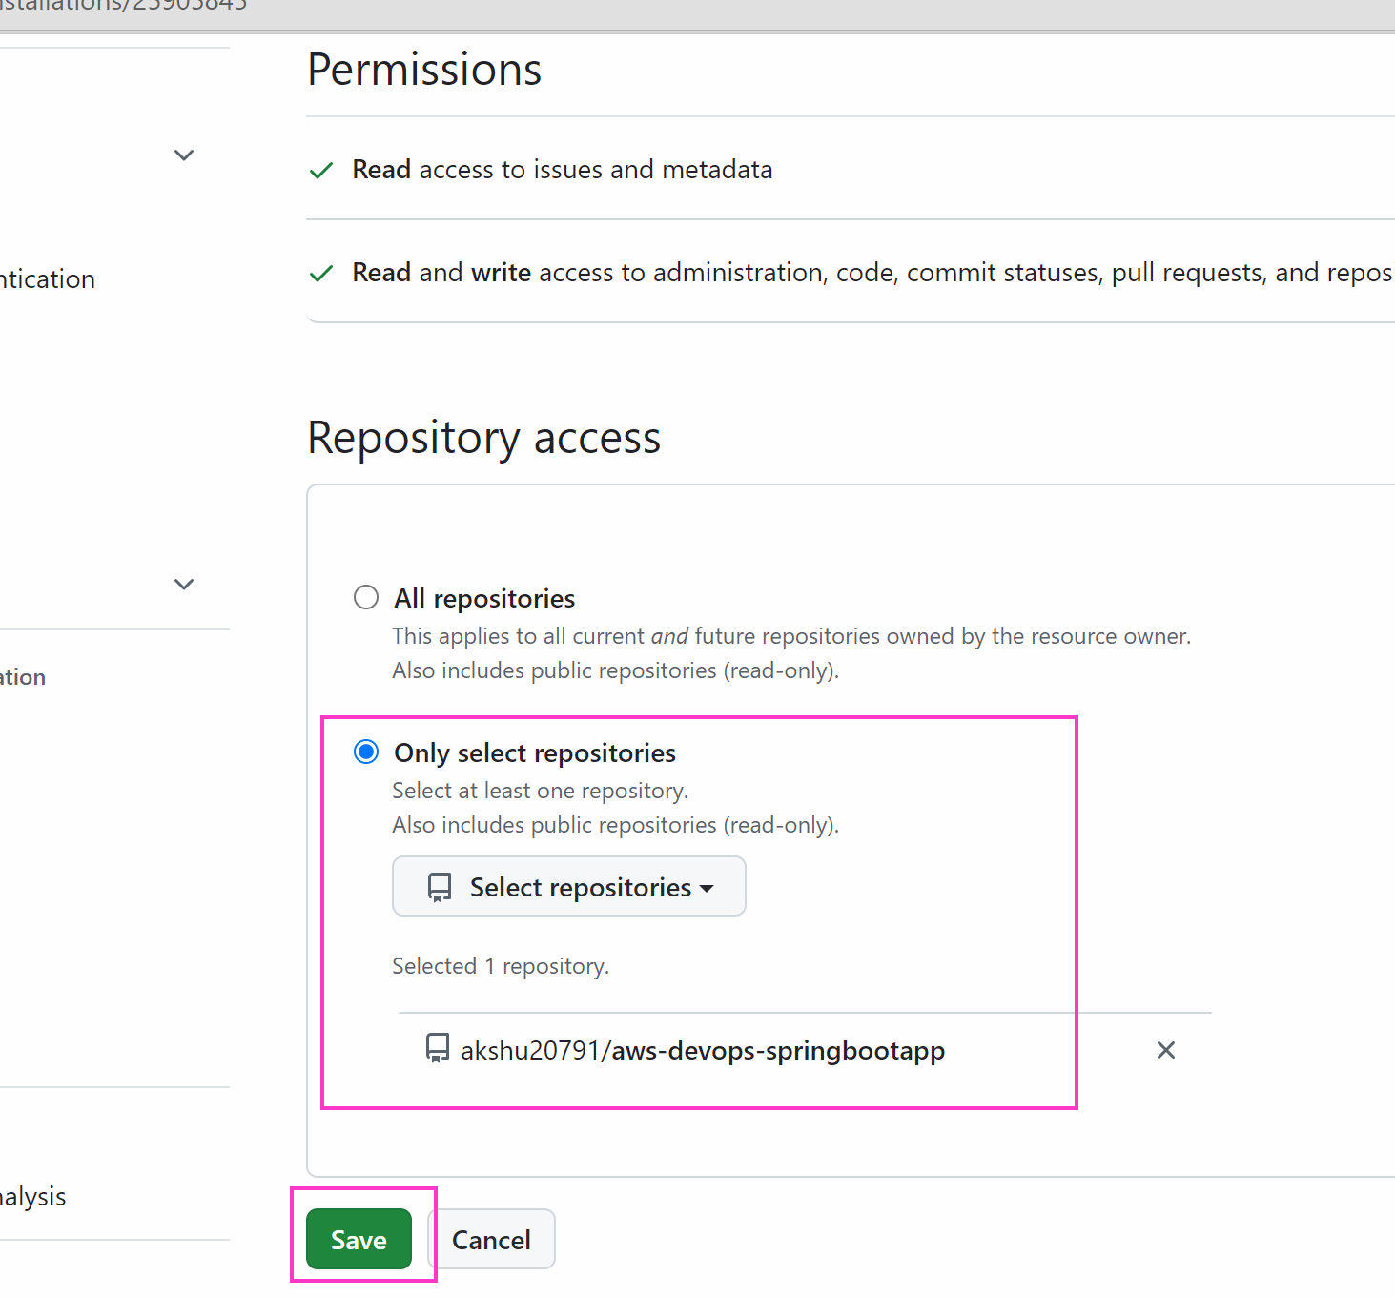

Connect

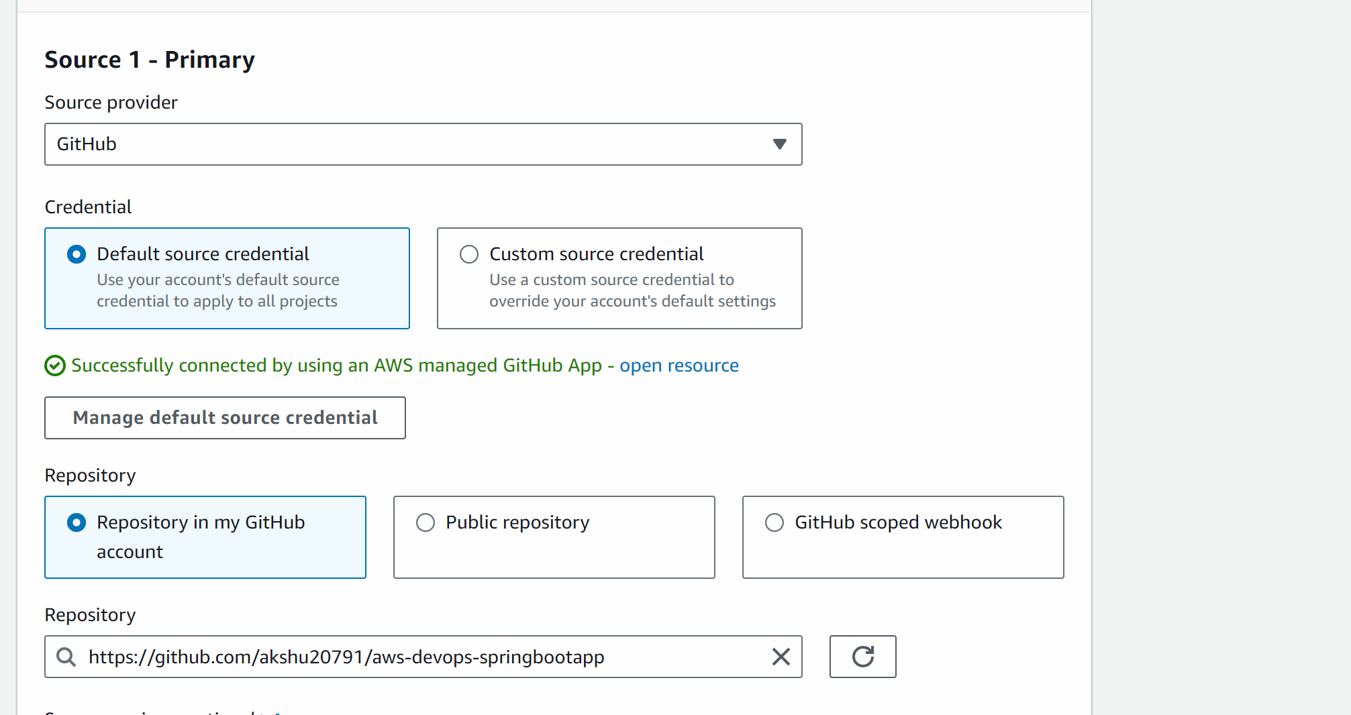

Scroll down

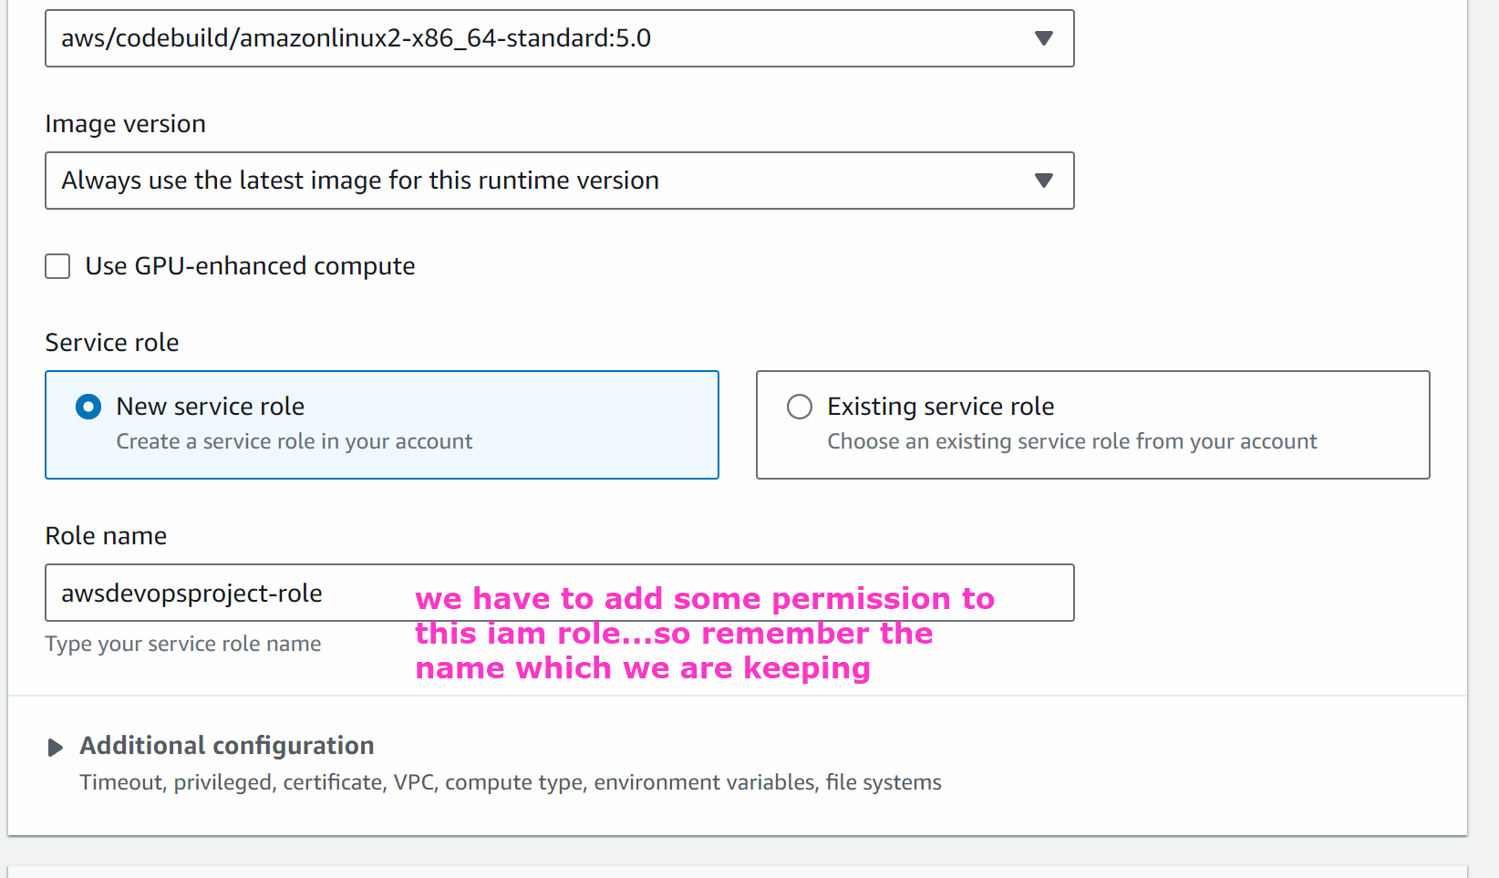

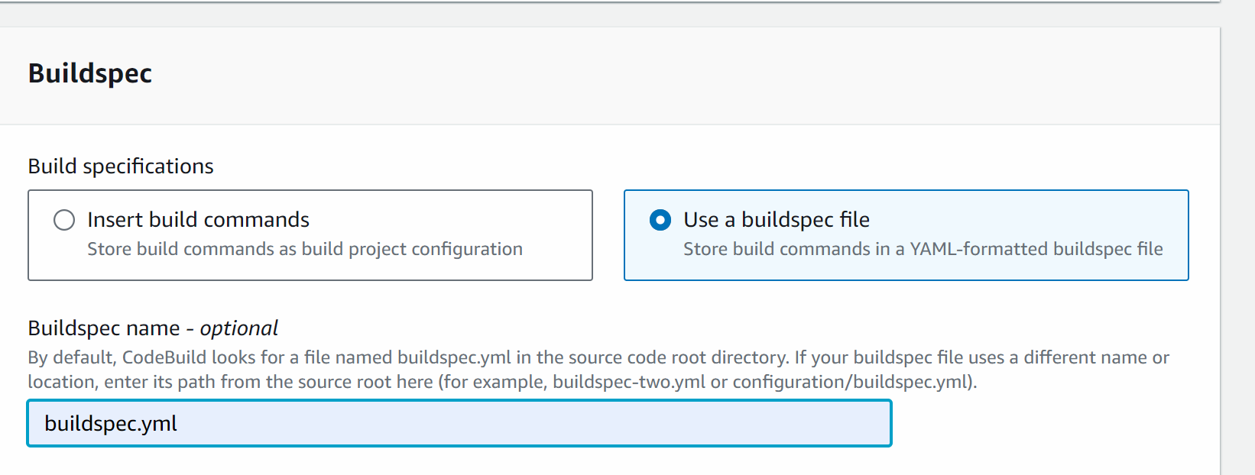

Create the build project

#####

YOU WILL GET BUILD FAILURE (BUT DONT WORRY …CHILL :) )

Now when we build the image we will see the custom image is build on ECR but the problem is the code build does not have the permission to access ecr and ecs resources…this we need to give

Go to iam -> roles -> select the role which created while create aws code build

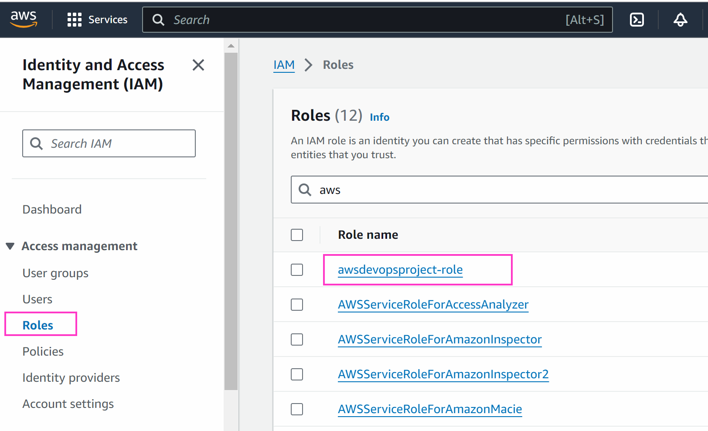

Add permissions -> attach policies

Add administrator access

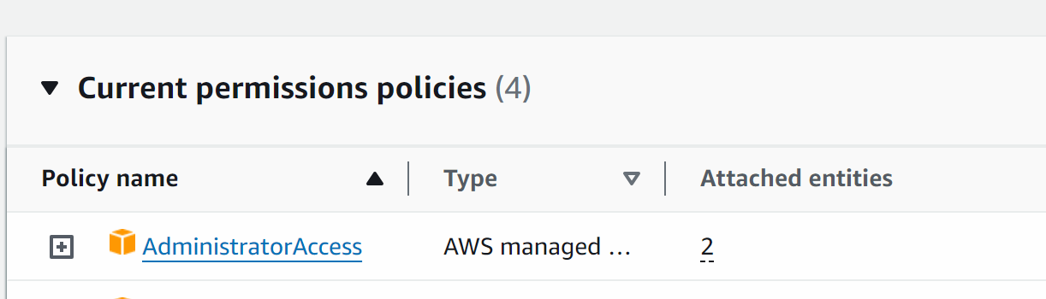
And also

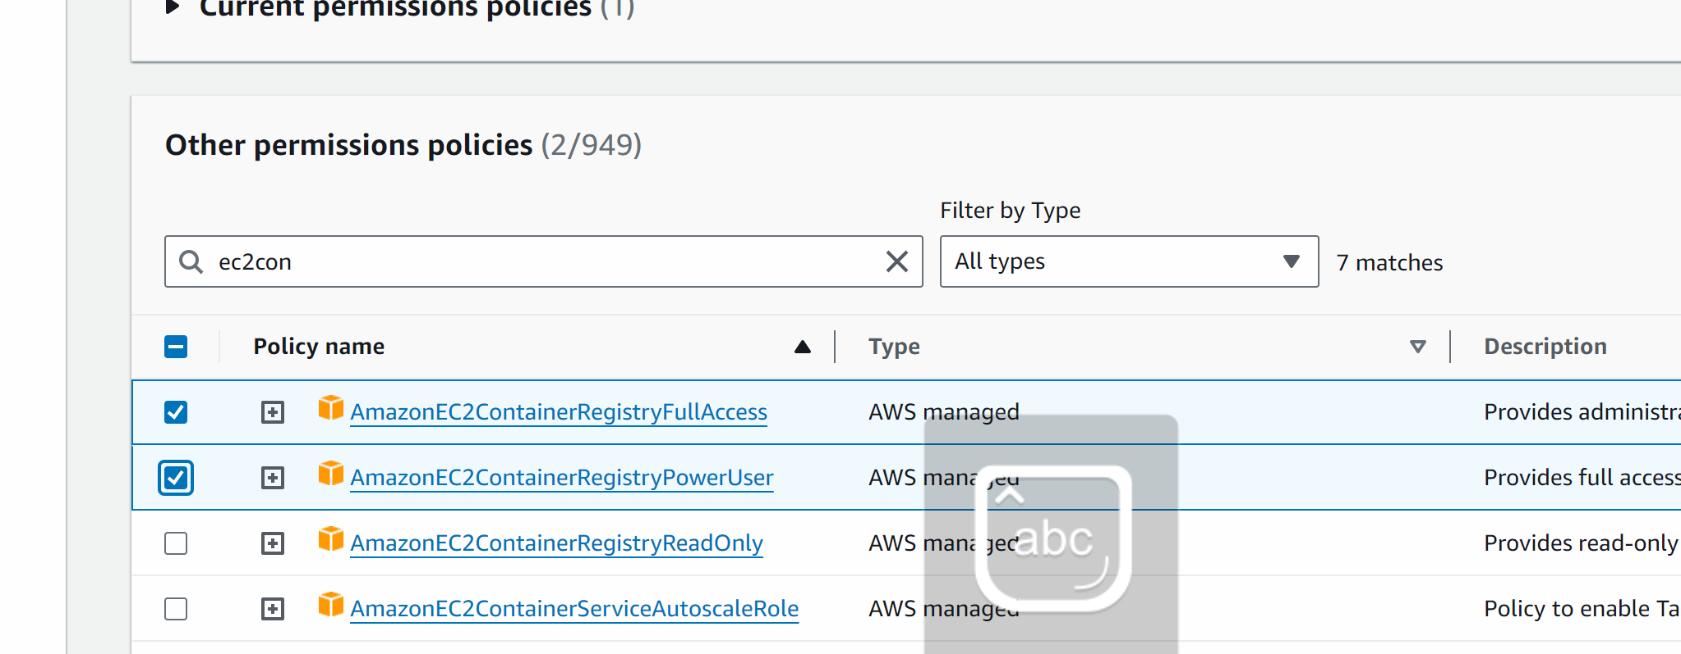

Add permissions

#############

Now we will build our code build project

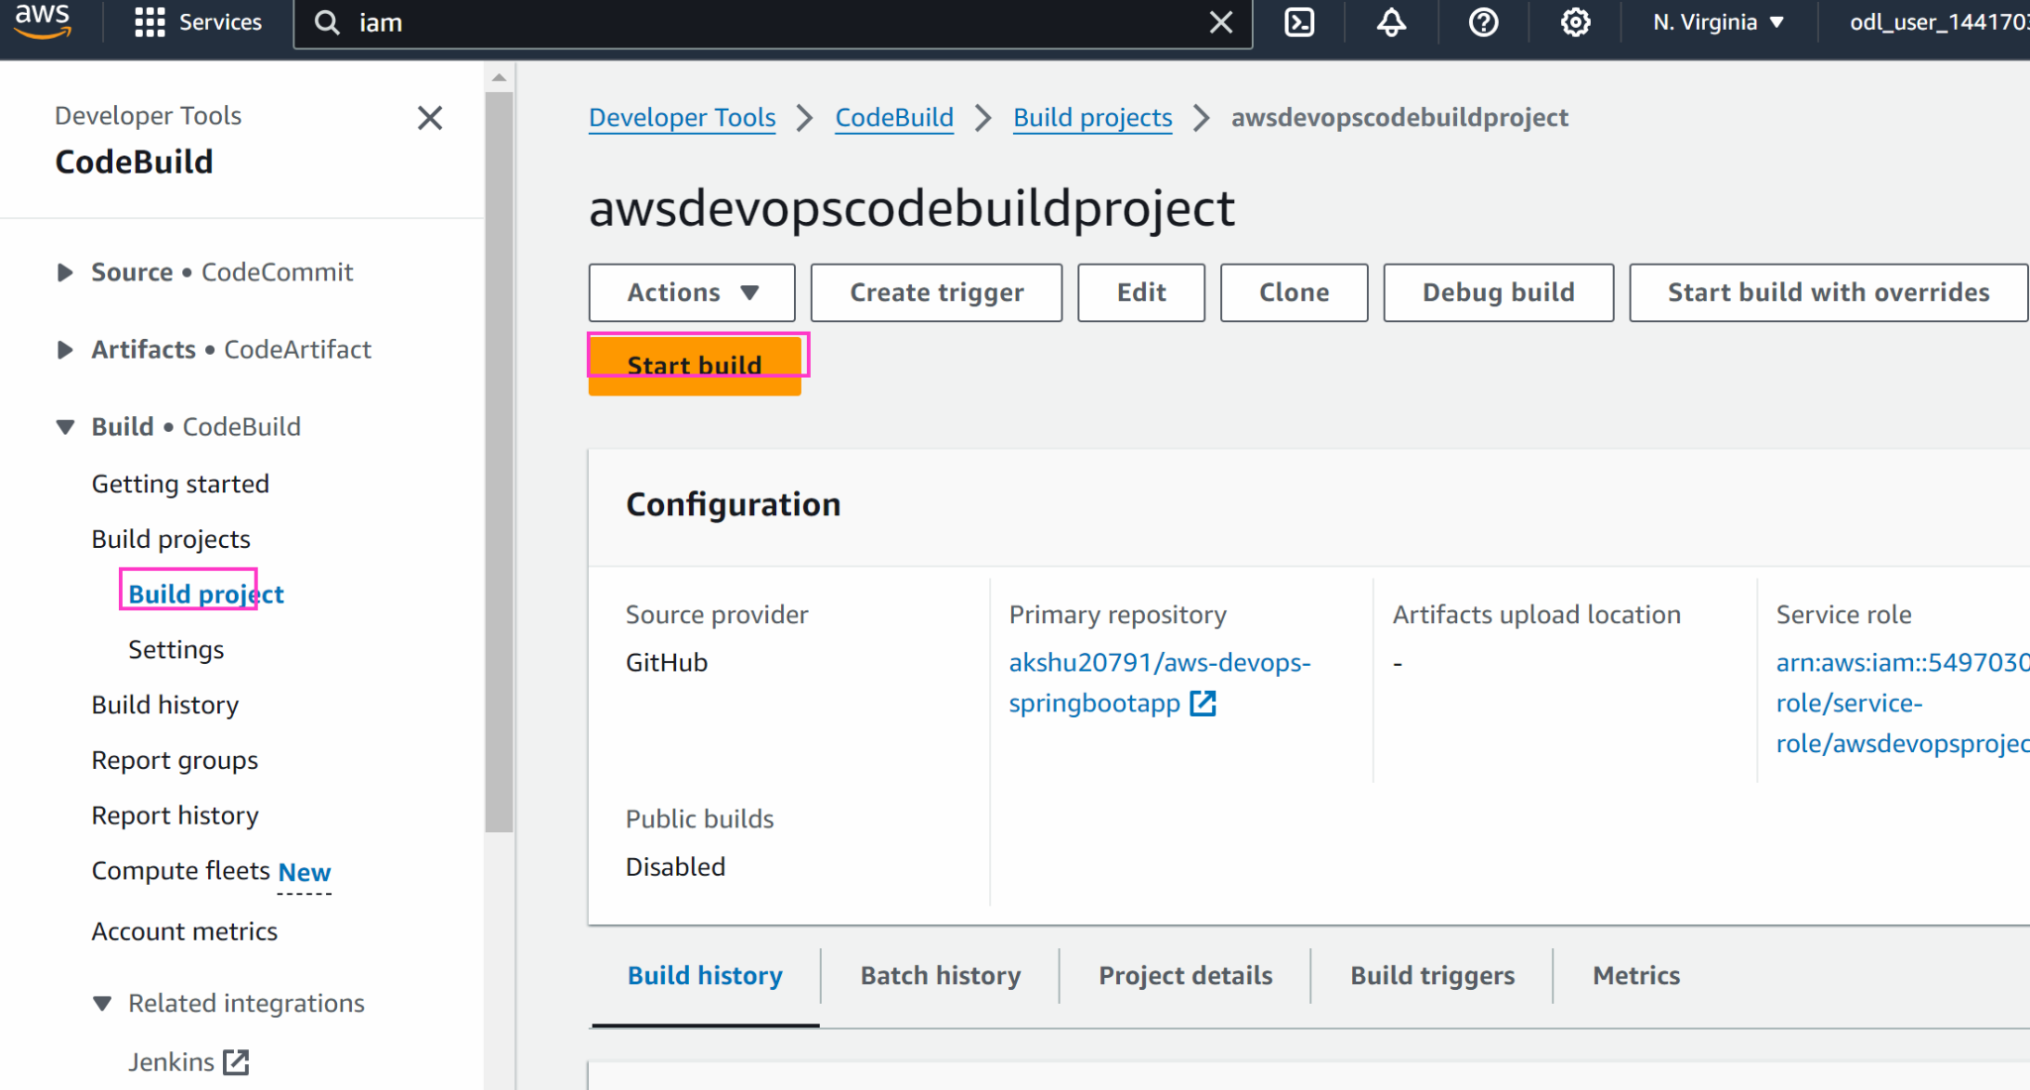

You will see that your build is successful

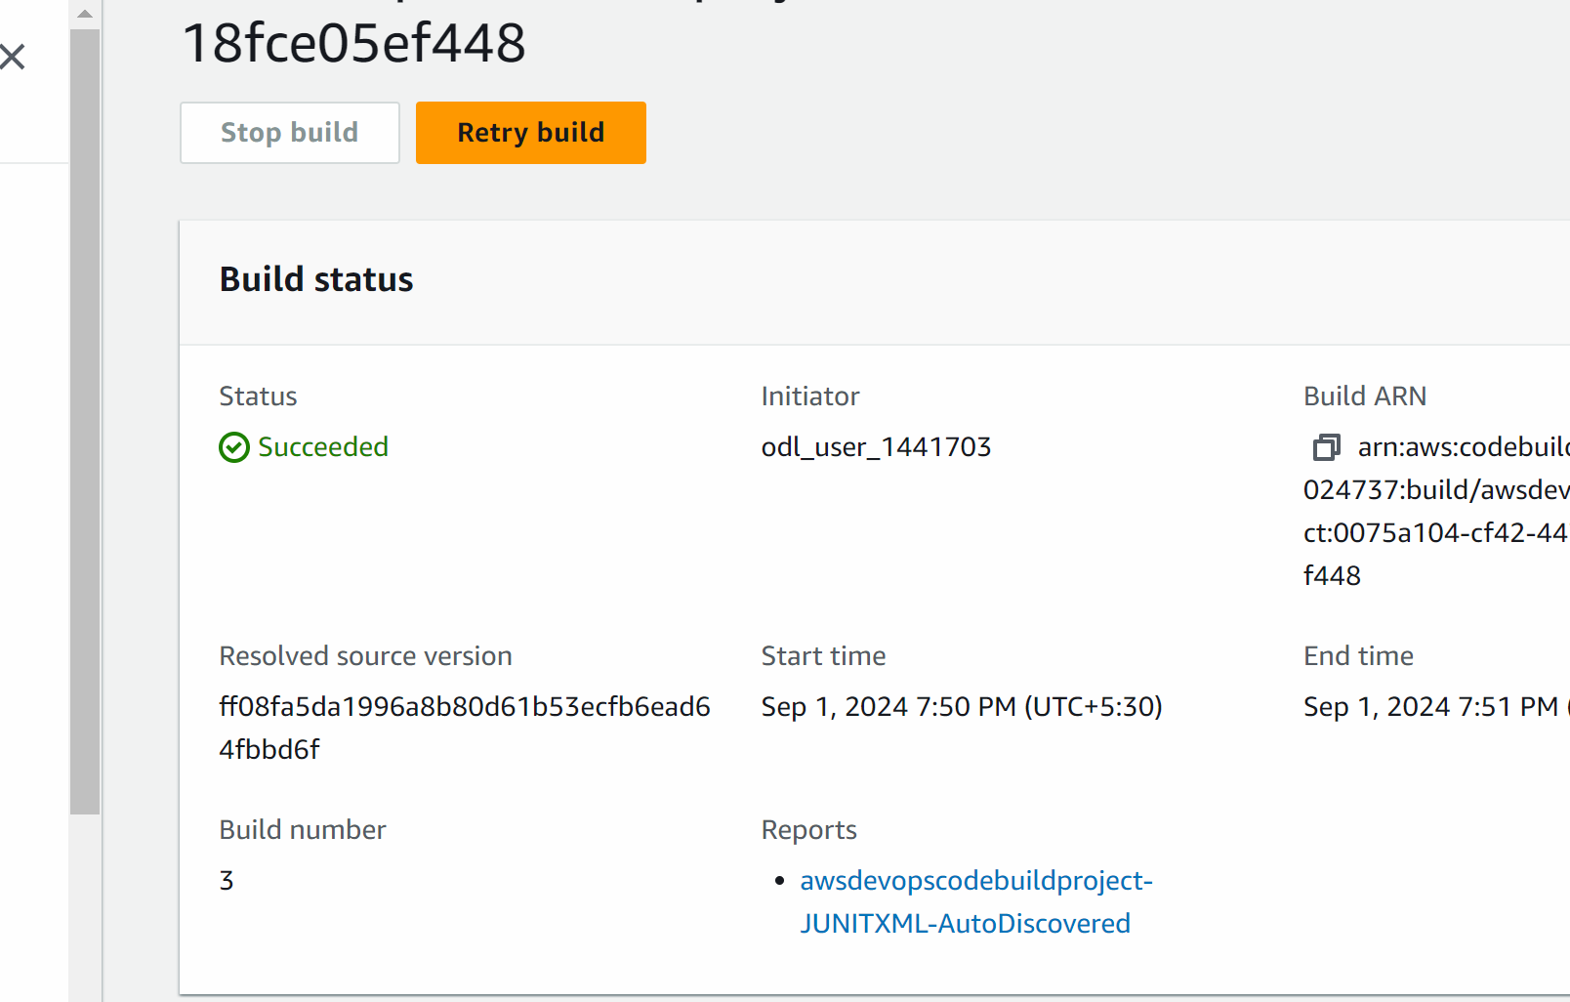
####################################

#########################################

Now we want to deploy the project…but we need to create ecs tasks and service

Go to ecs -> create ecs

Create cluster

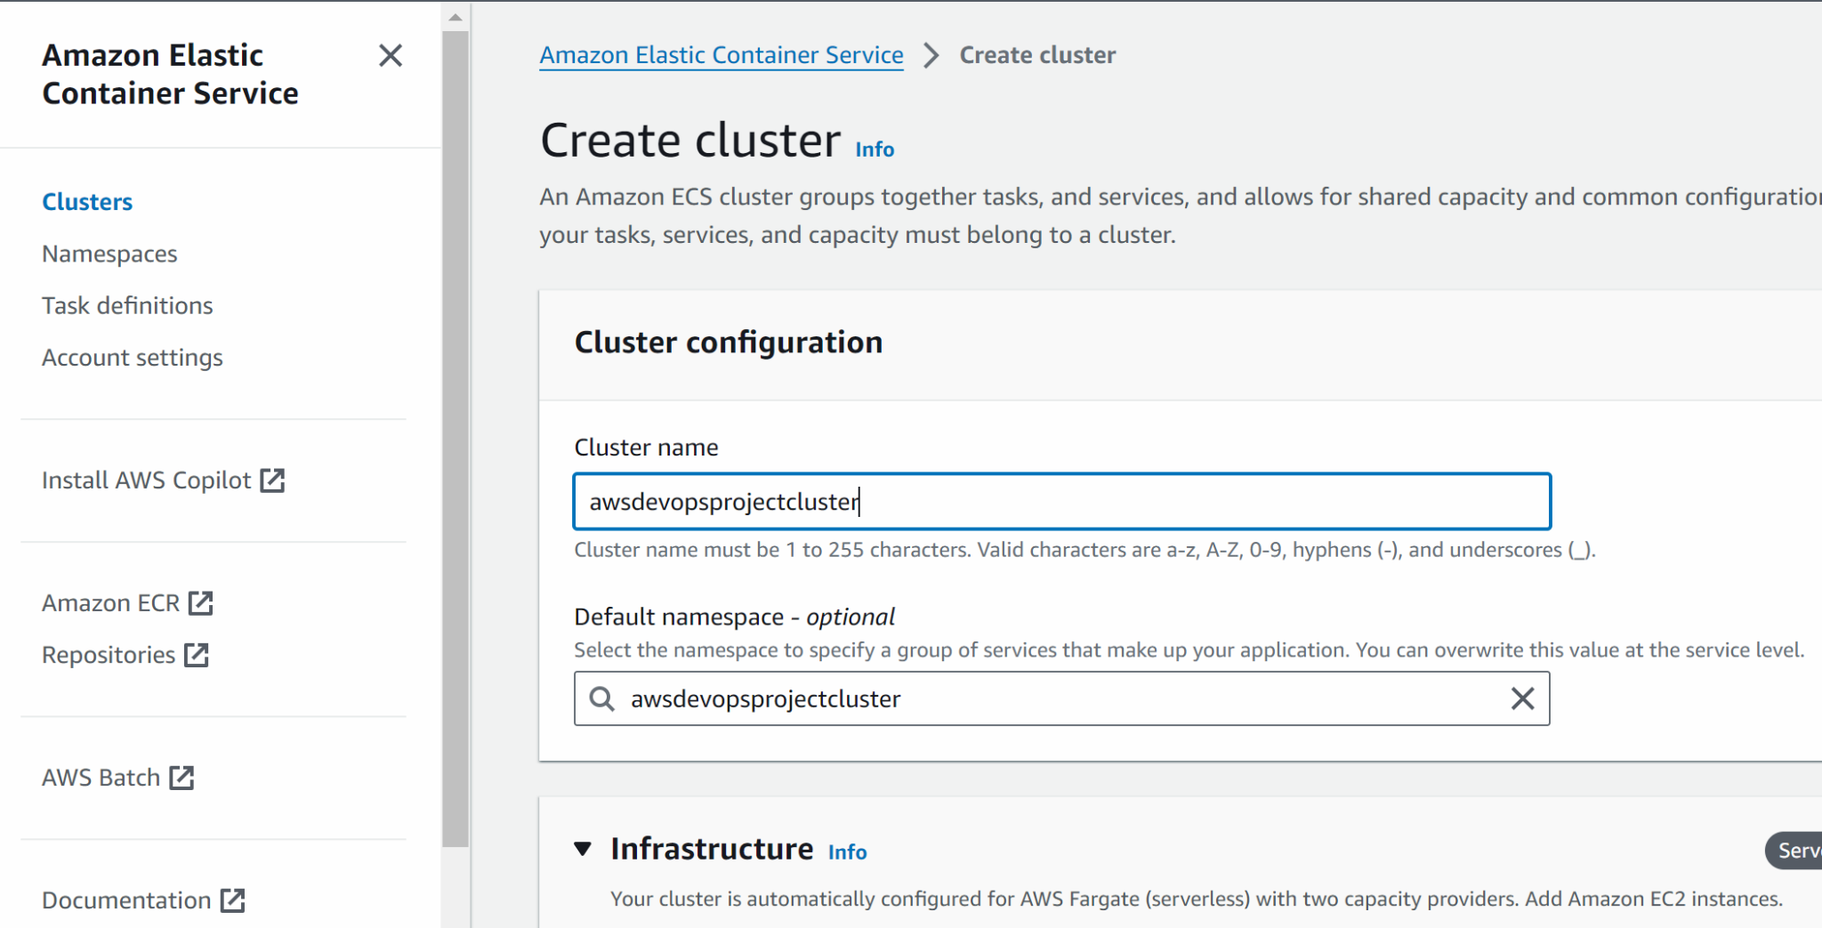

Select fargate
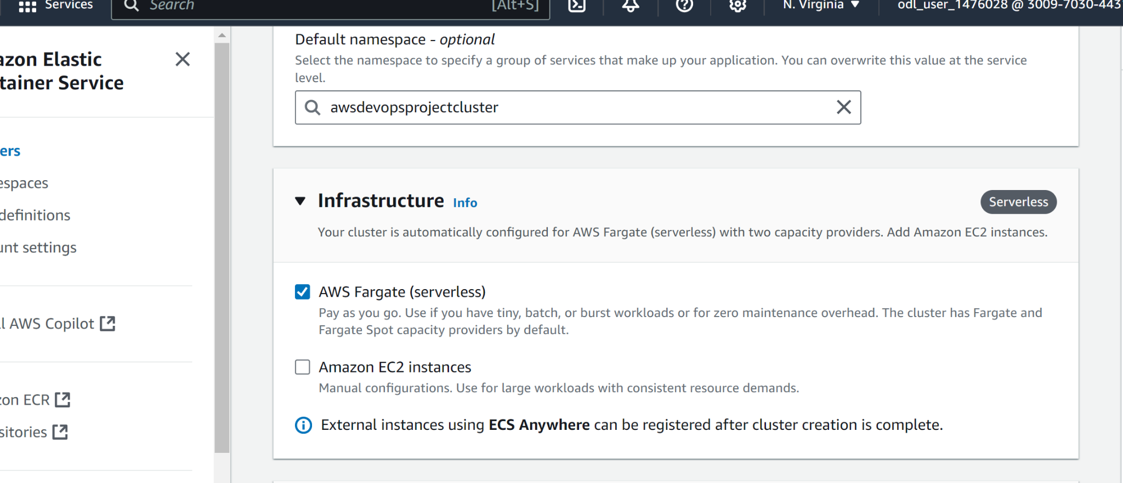
Create
(If you get error in creating the cluster recreate it again until it is successfu)
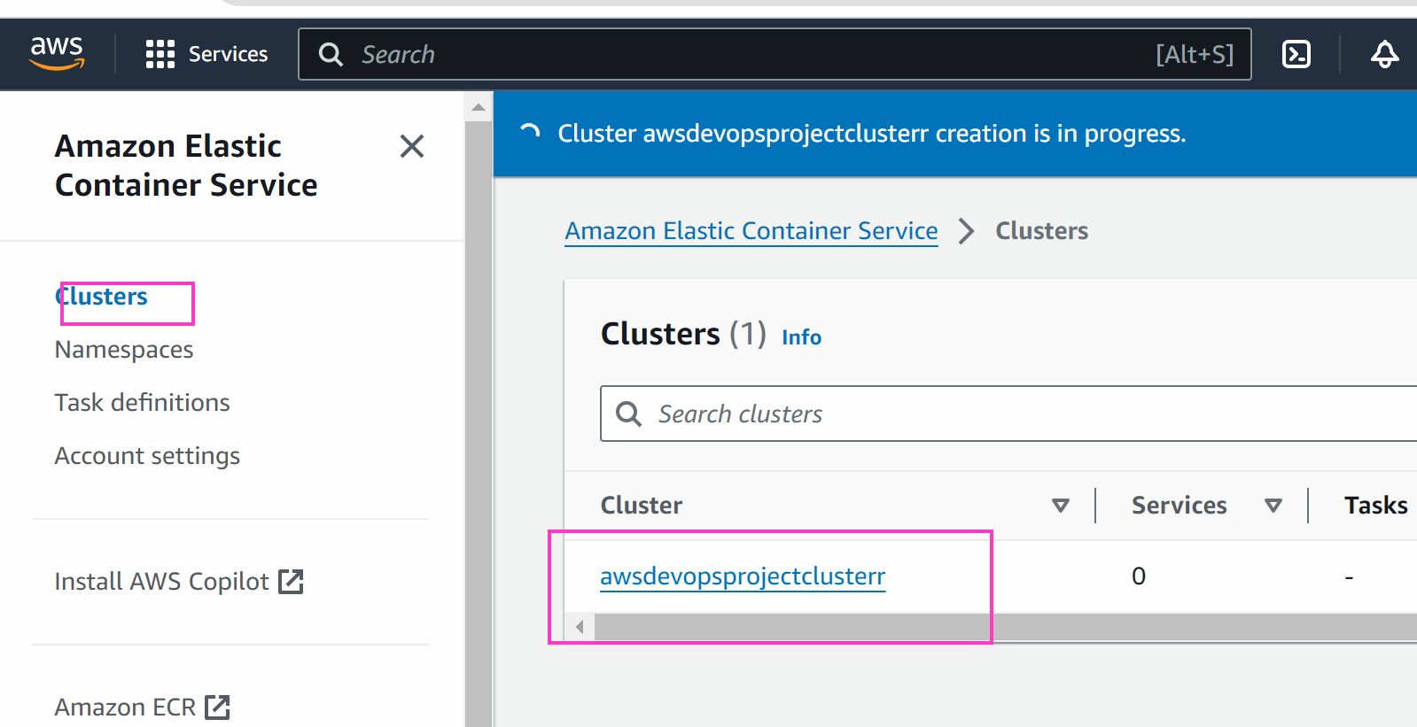

Now we will create tasks

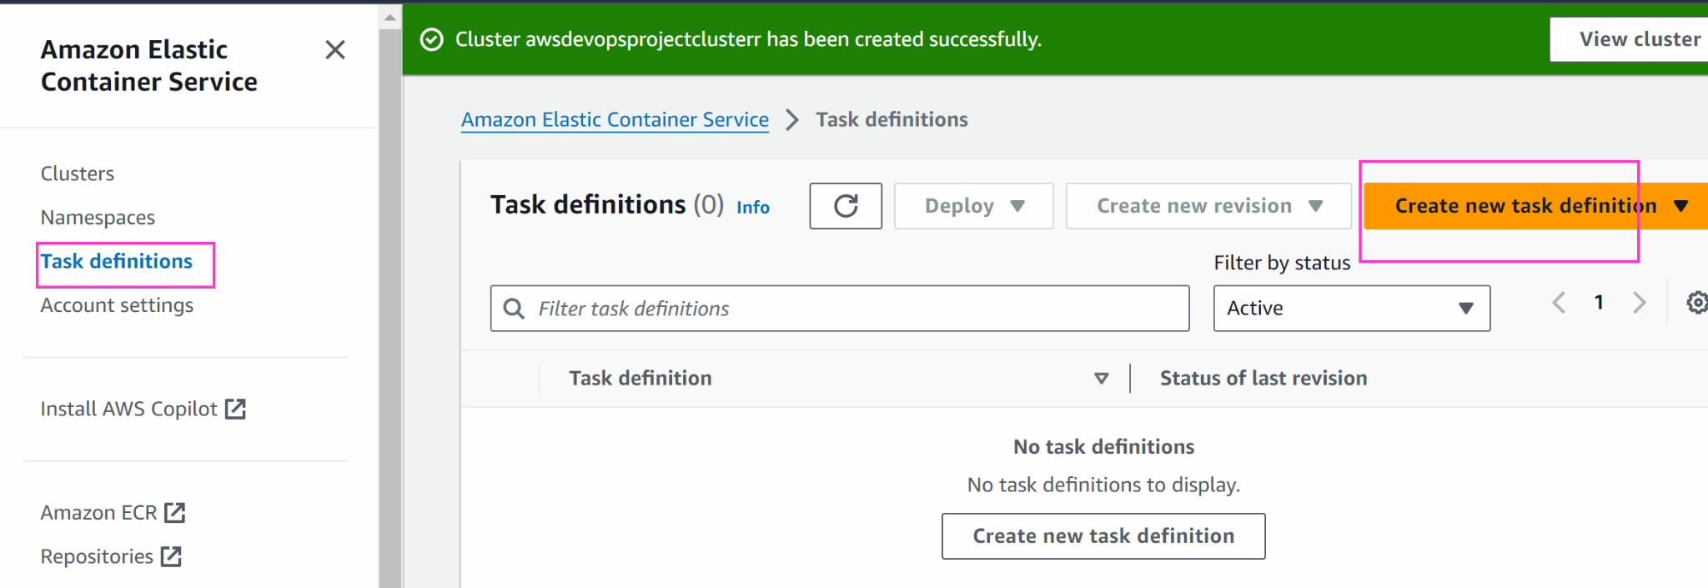

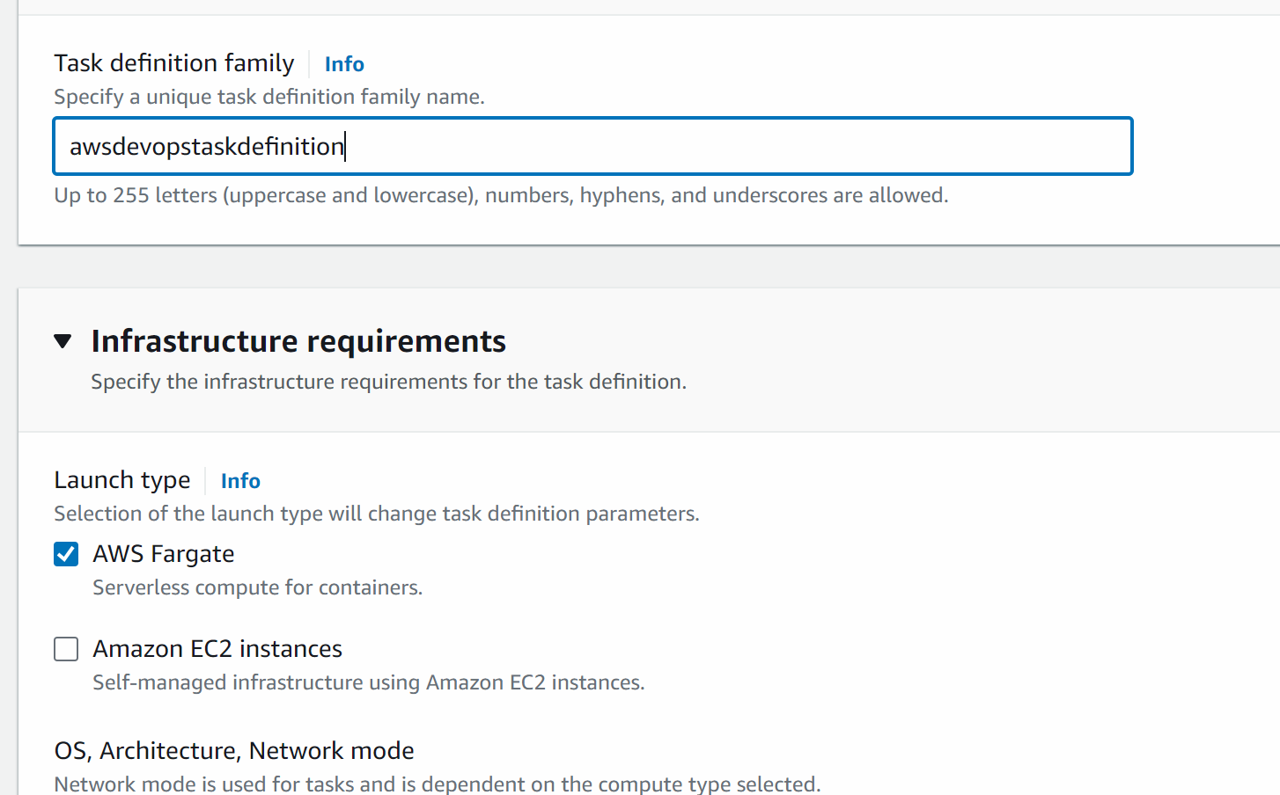

Scroll down and keep the name of the container as spring-demo-ecr otherwise you need to change the name of the container from the buildspec.yml line number 29

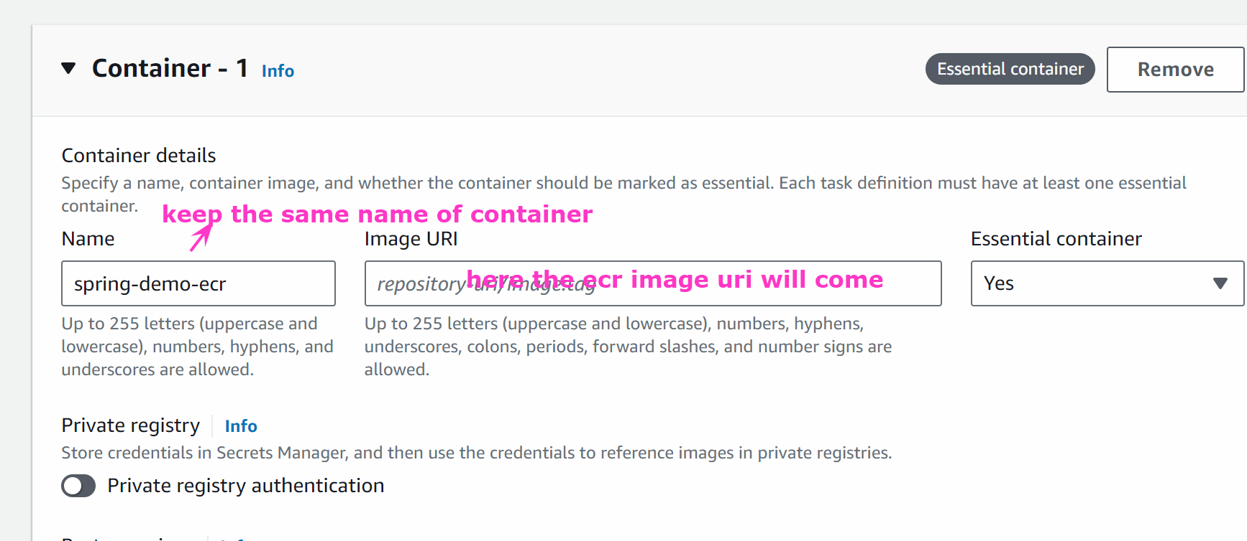

(you will go to ECR -> COPY THE IMAGE URI FROM THERE)

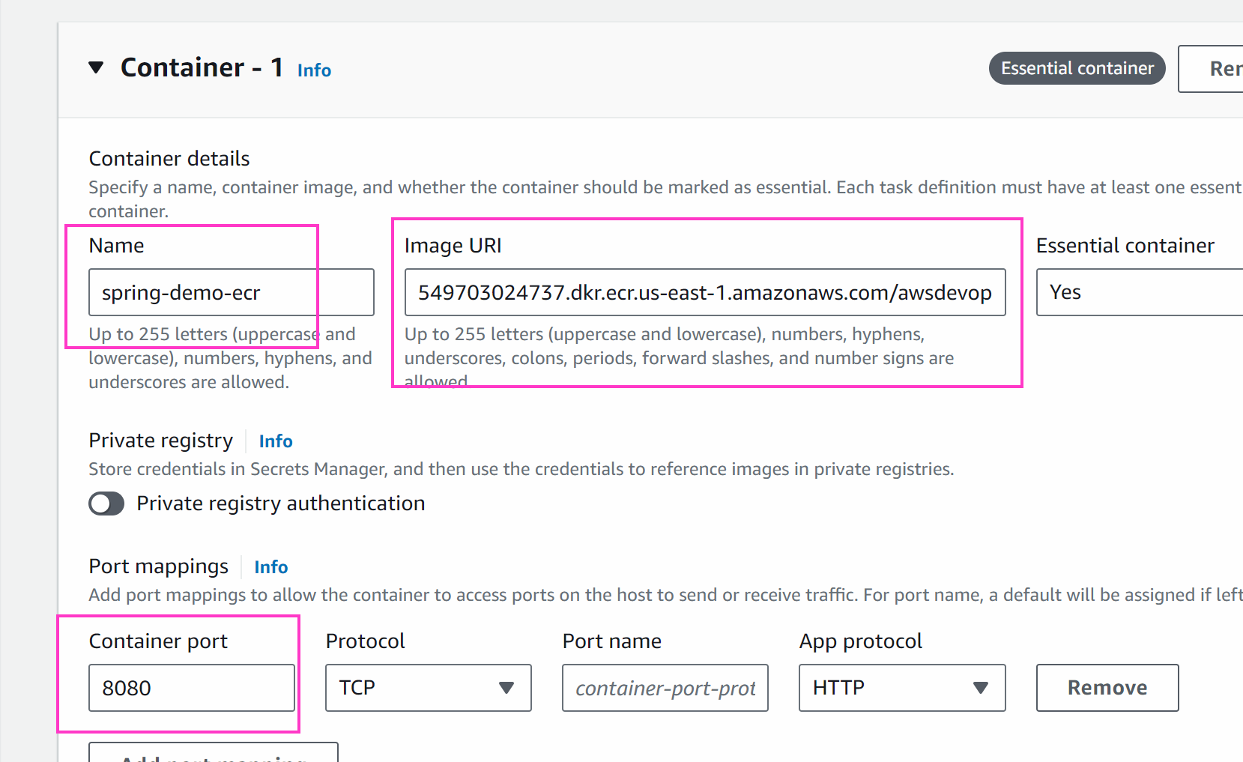

Create

Go back to the cluster and click on the cluster

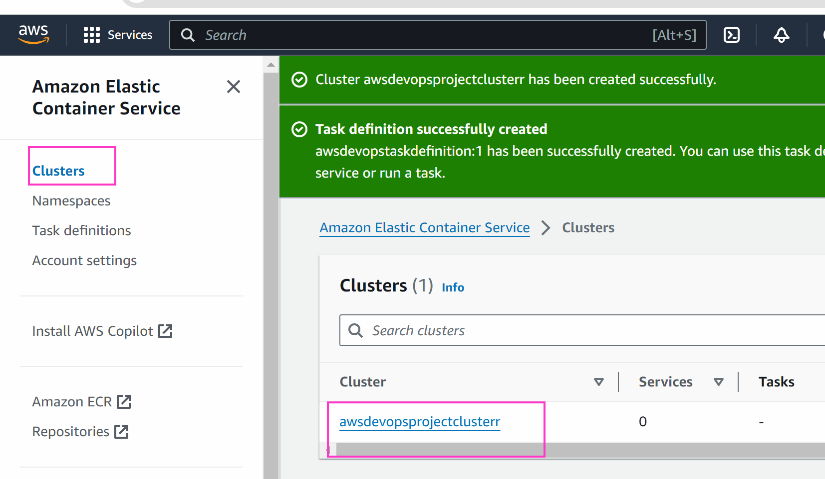
GO TO ECS -> CLUSTER -> CLICK ON THE CLUSTER WE CREATD
We will create a service

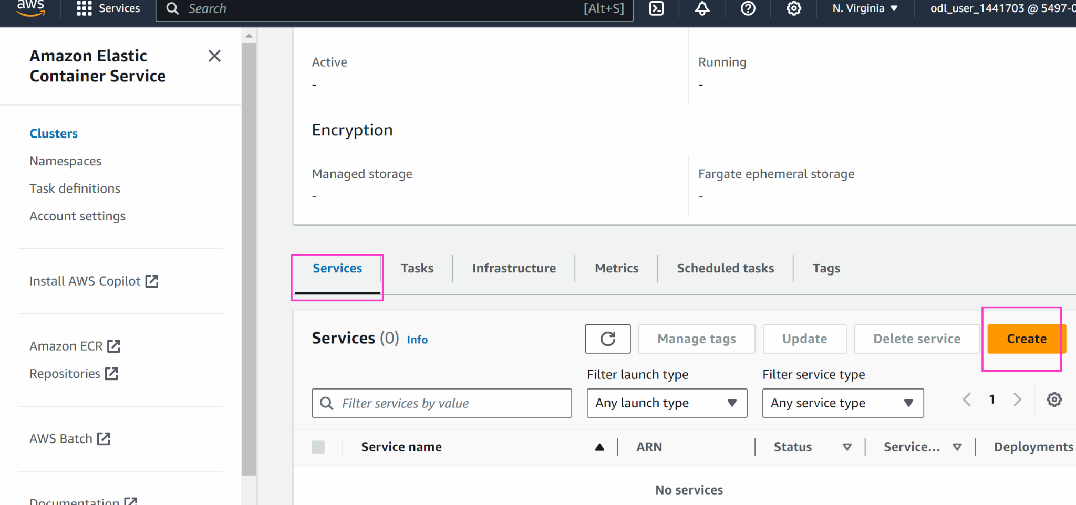

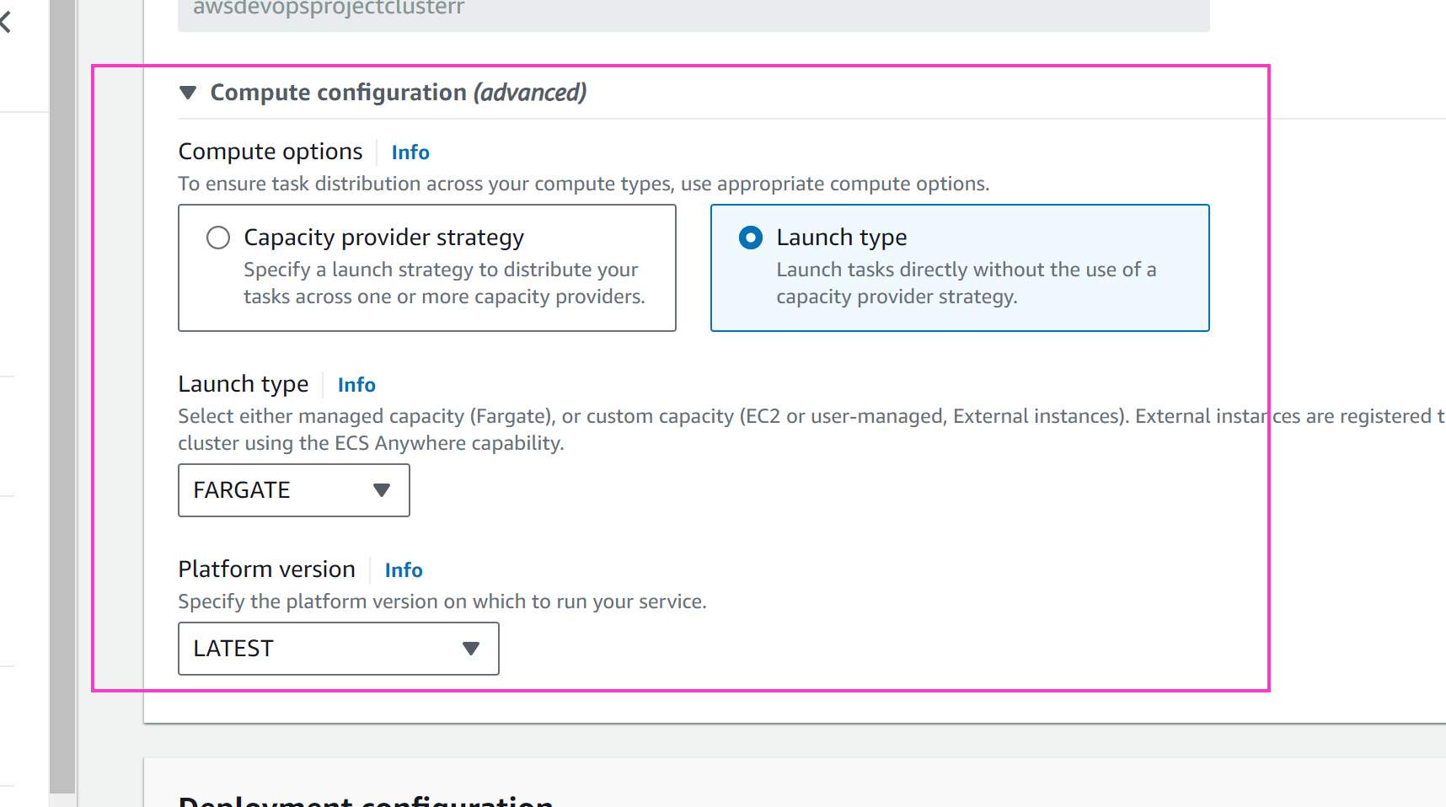

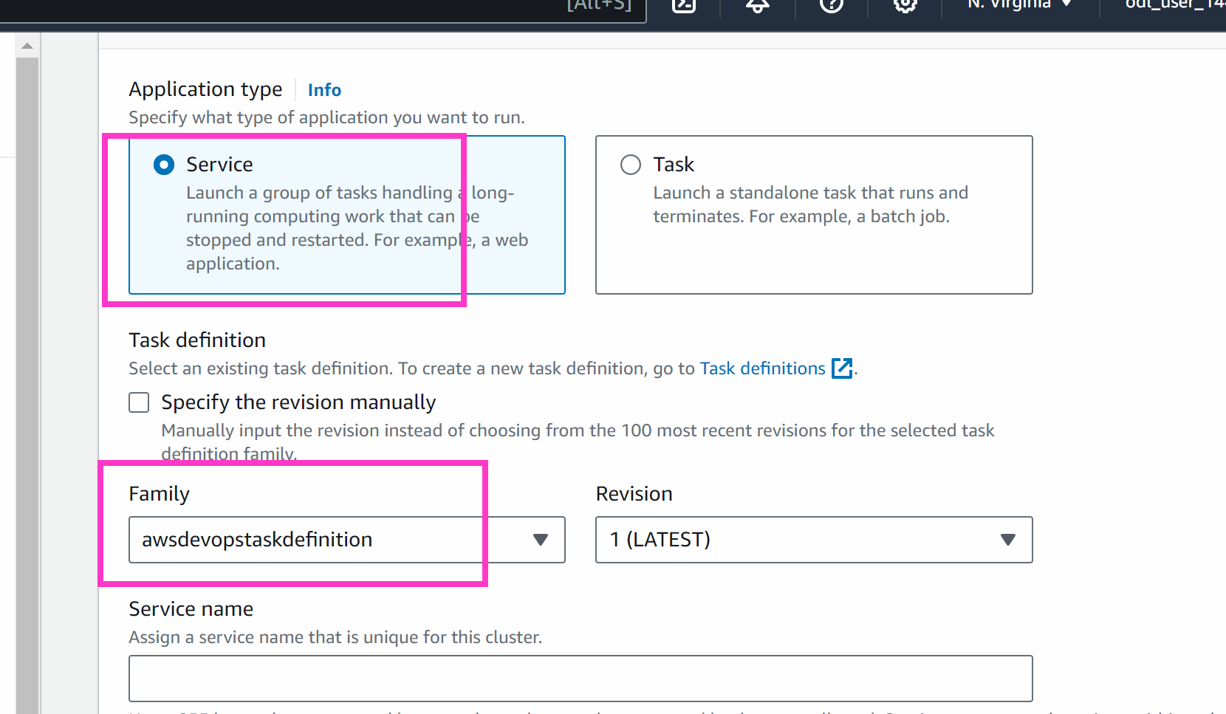

Keep any service name

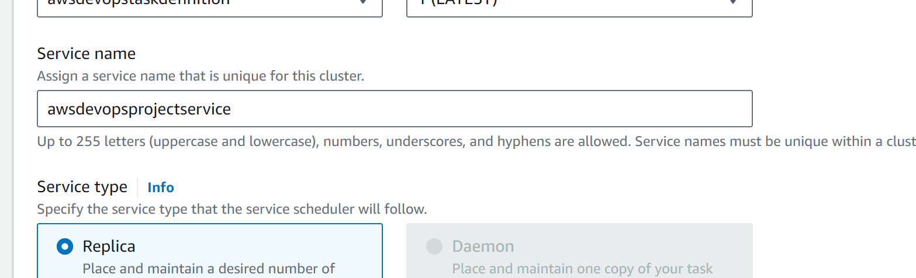

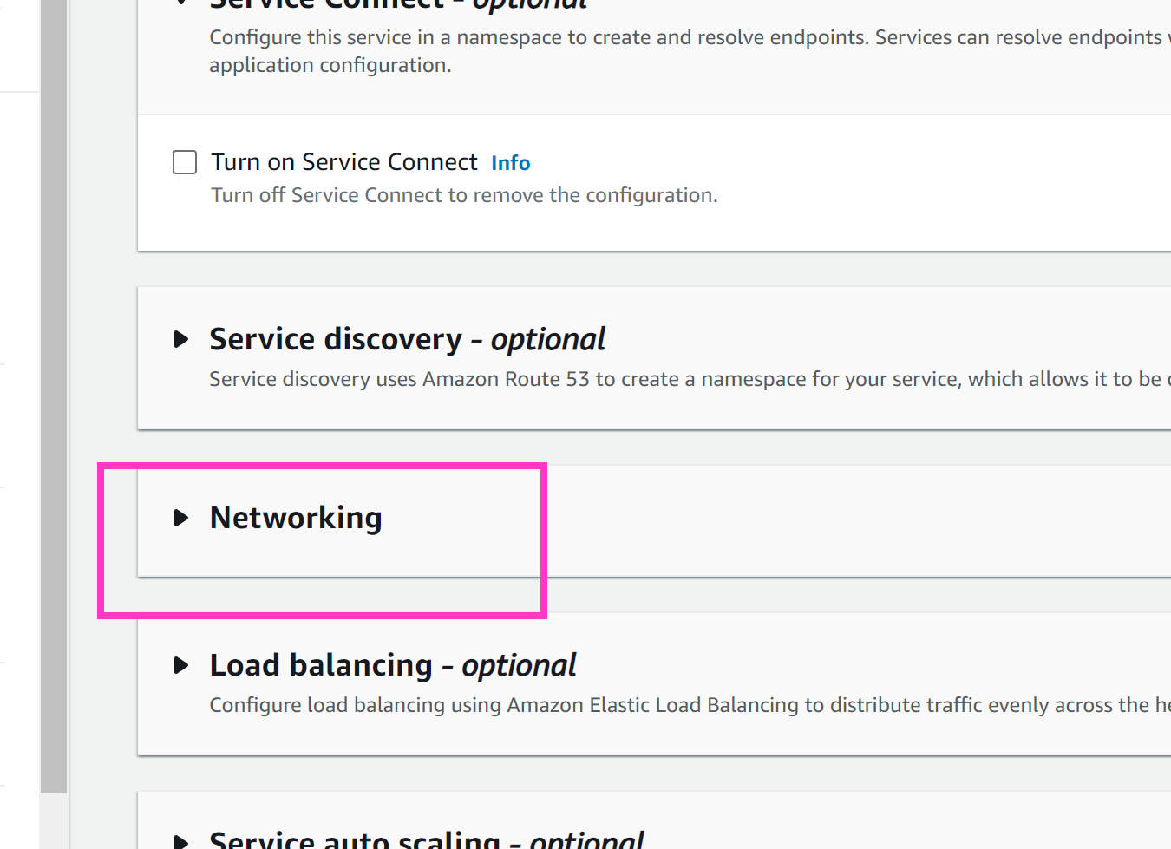

Create new security group and enable all traffic

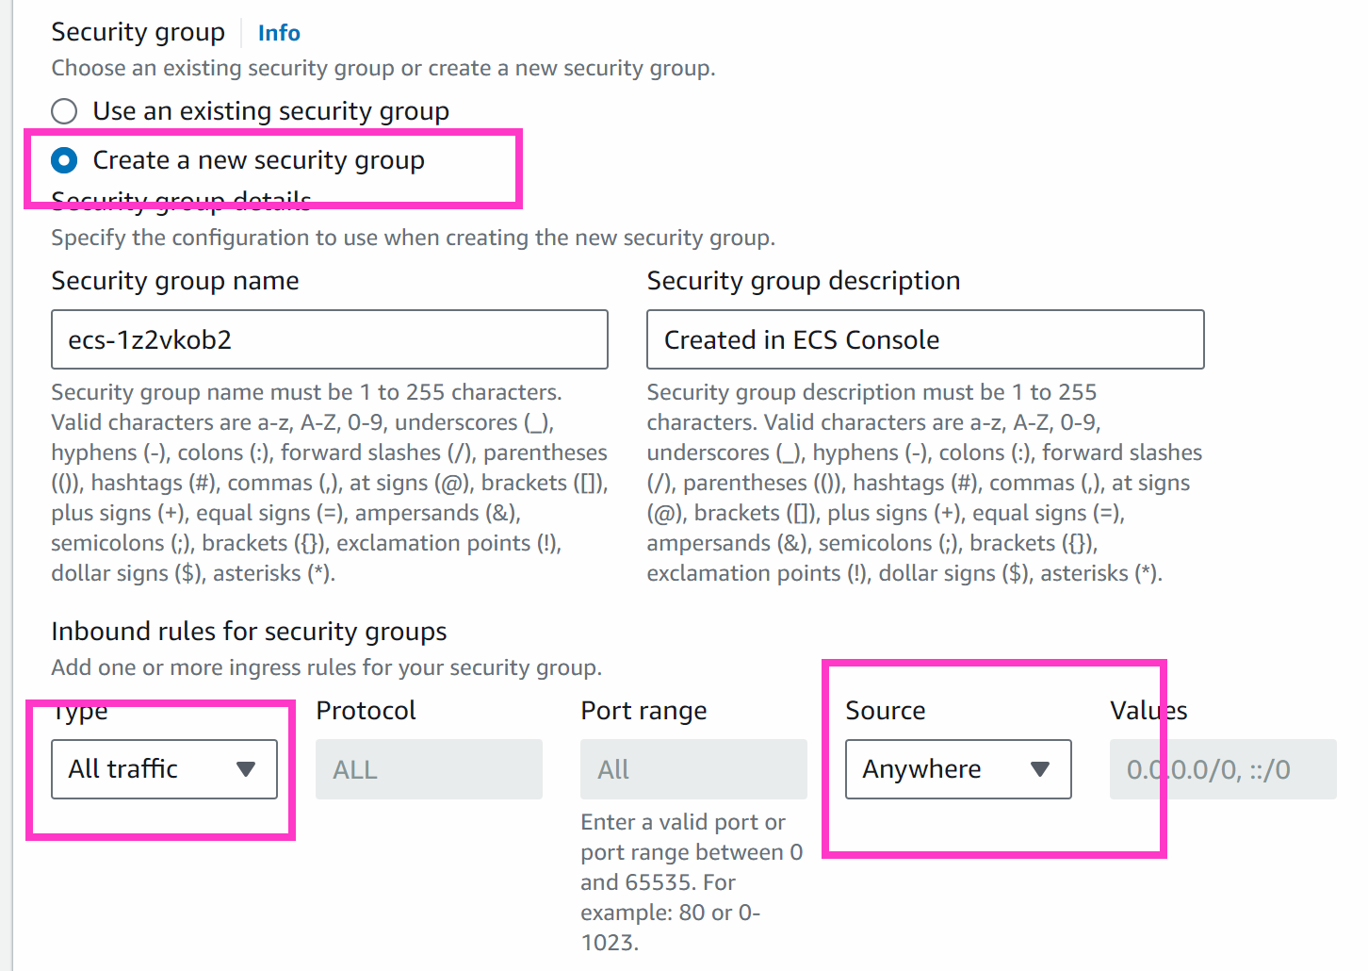

Create

Wait for 2-4 minutes

Keep refreshing
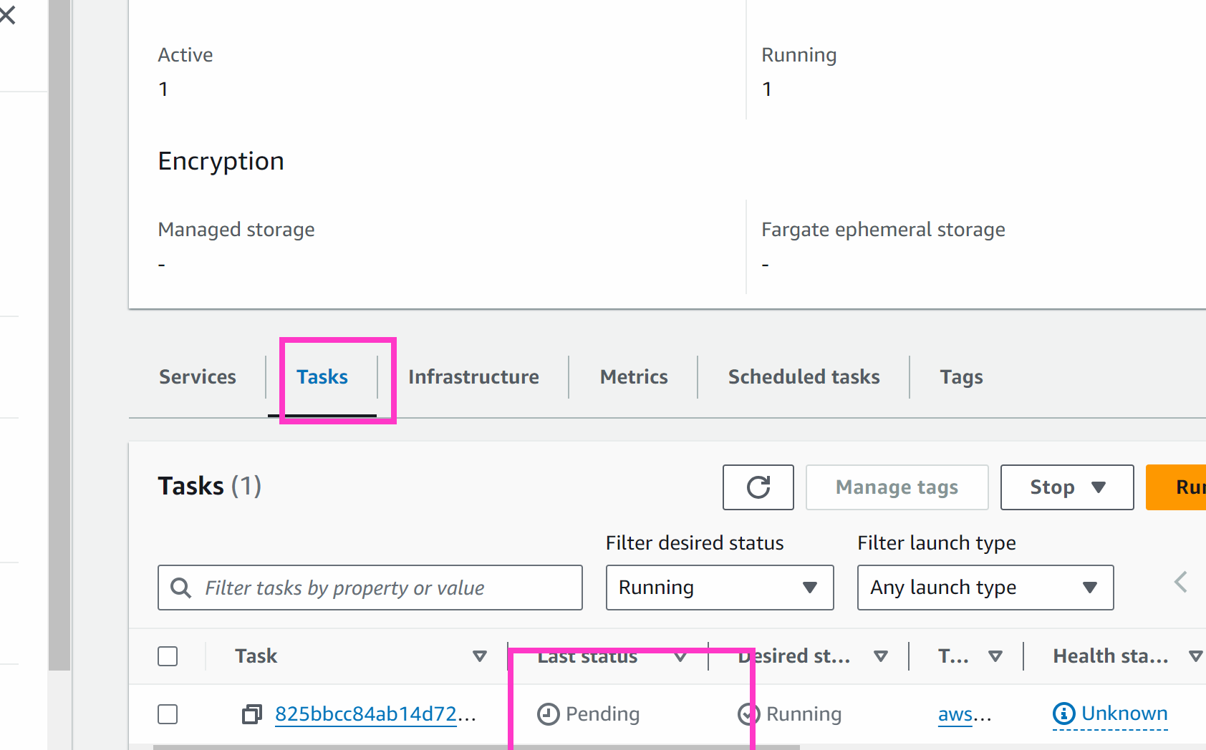

Wait for the task to change from pending to running

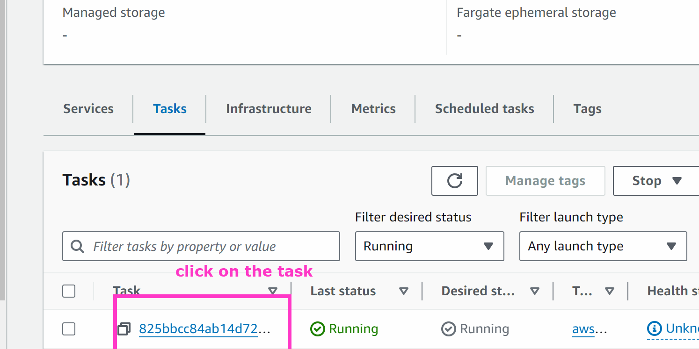

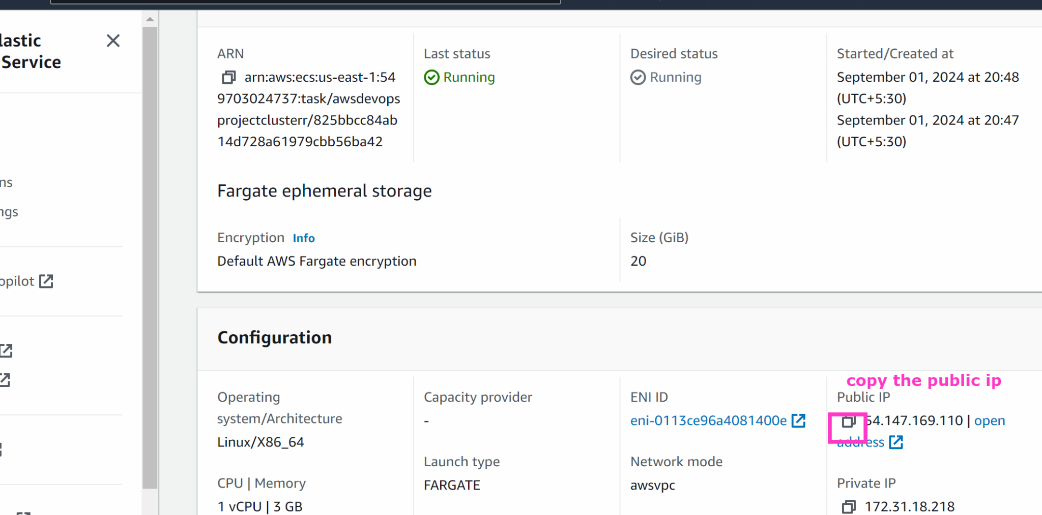

Open it in browser and put :8080/demo/data

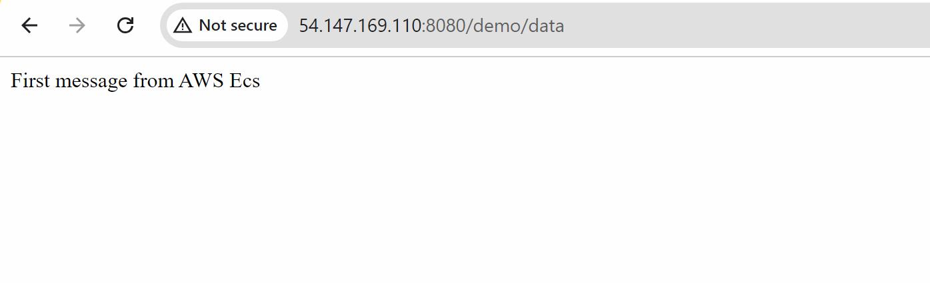

################################

Now we will build the code pipeline and automate everything in code pipeline

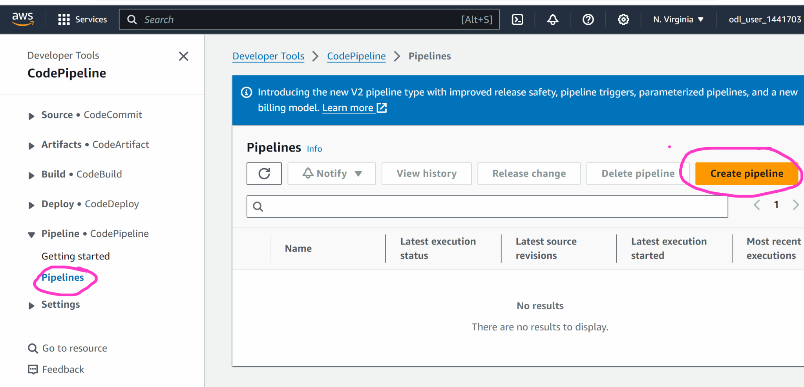

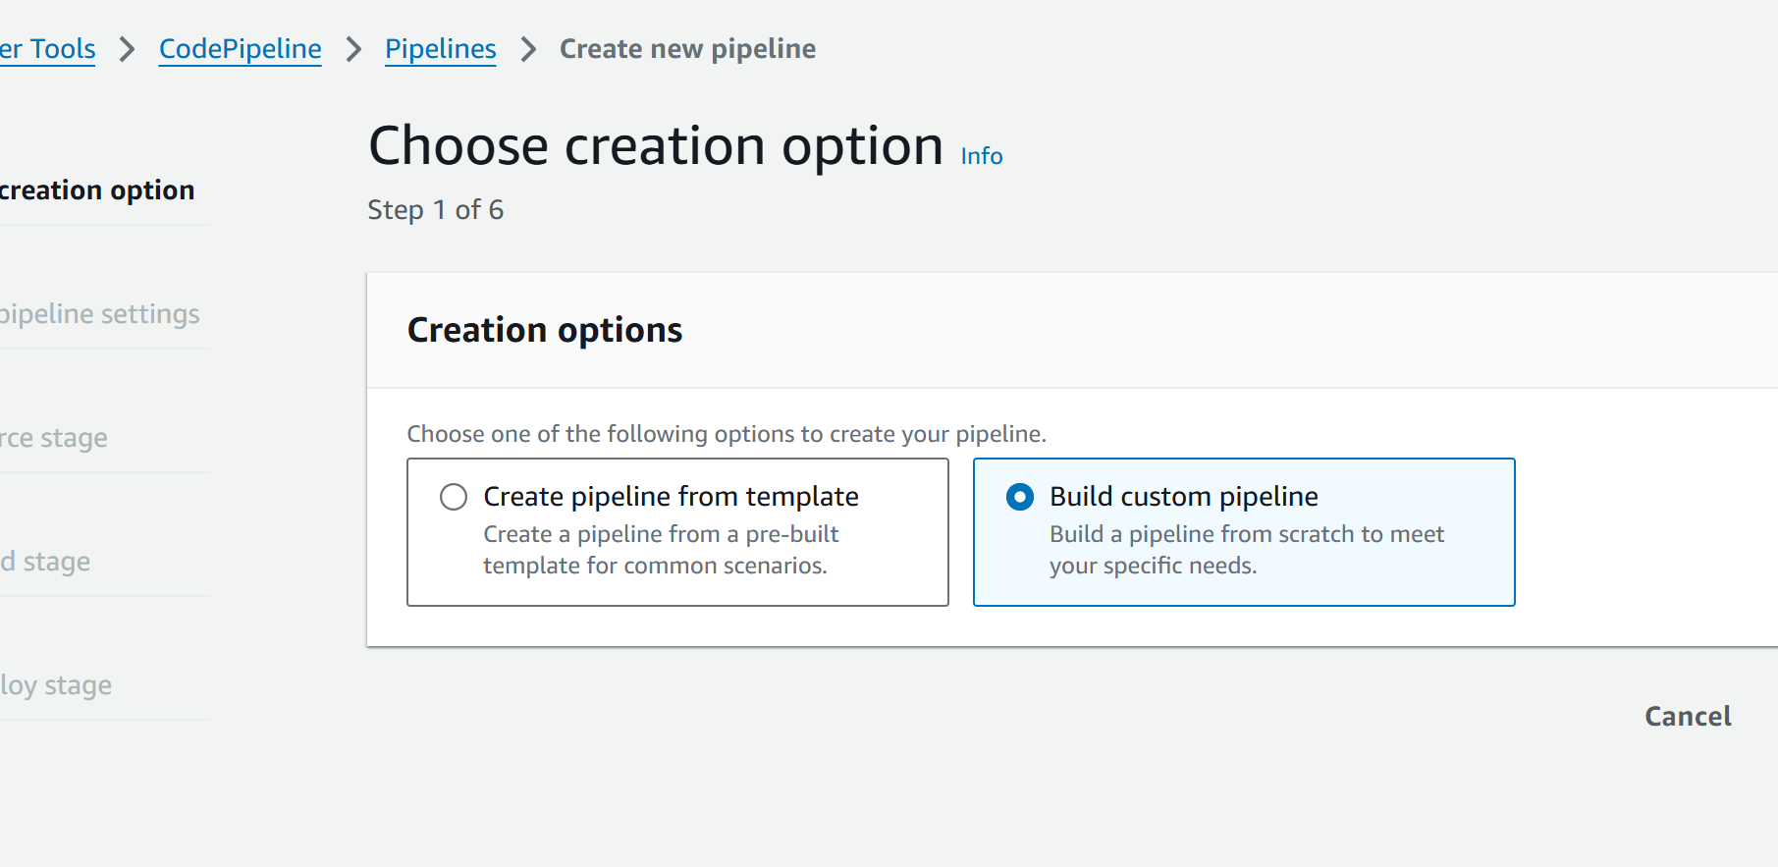

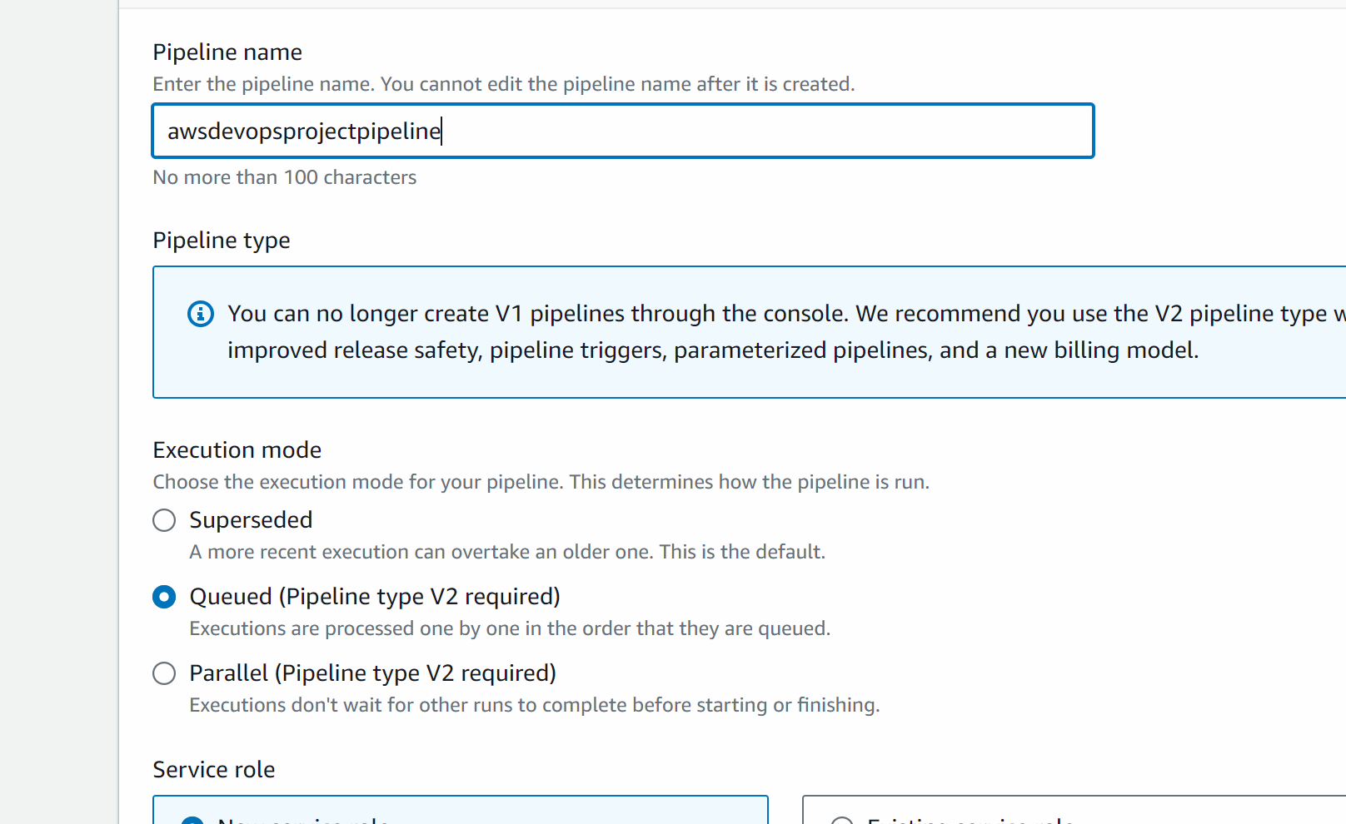

Next

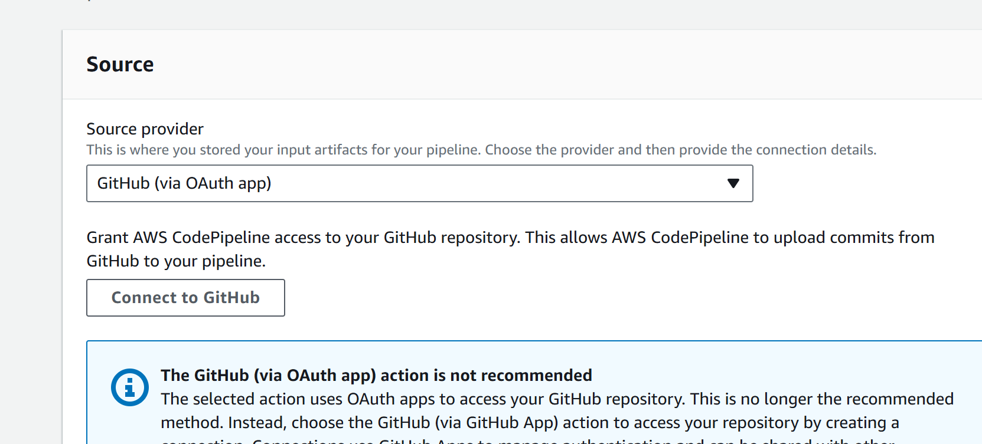
Connect to github

A popup will appear

Select authorise code suite

Connect

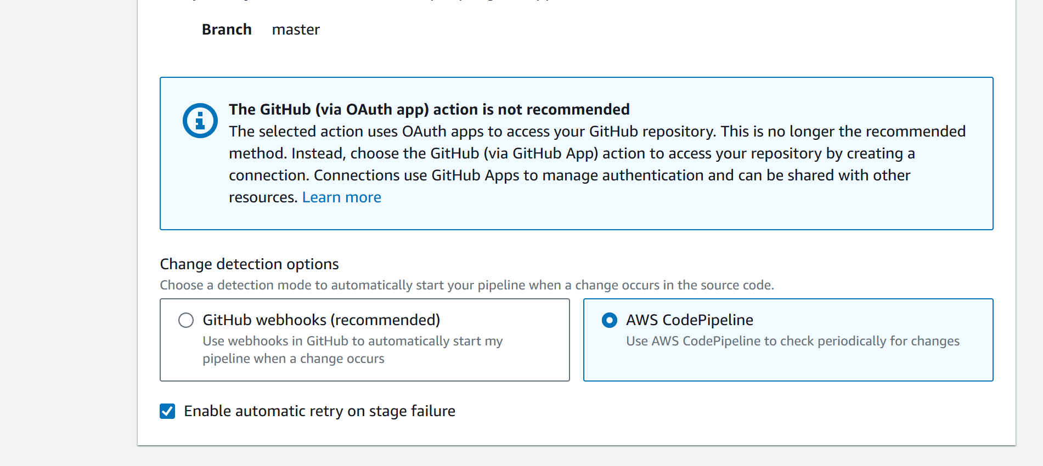

Next
Click on other build providers
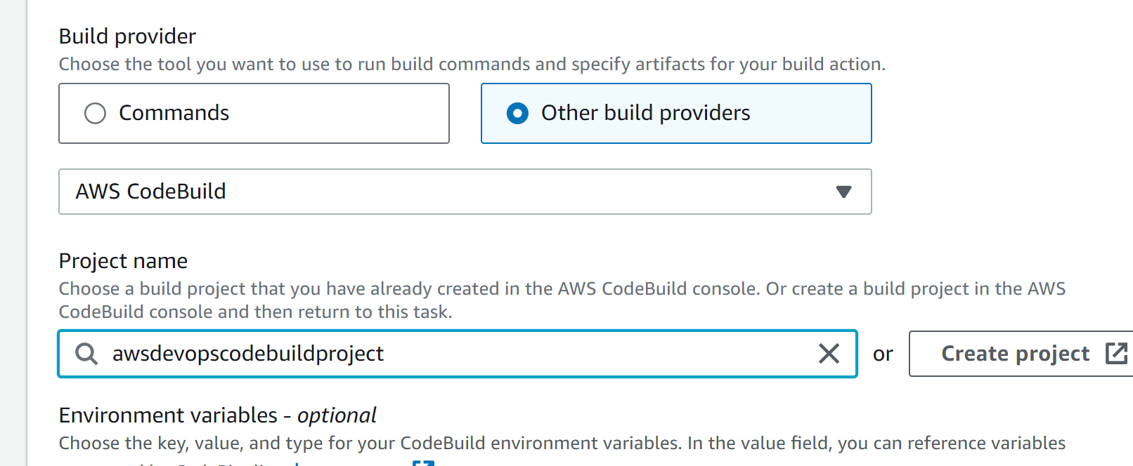

Next

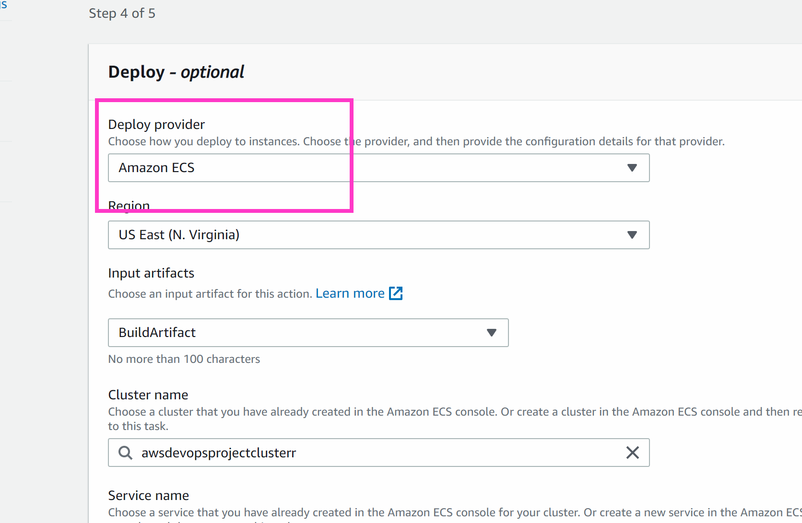

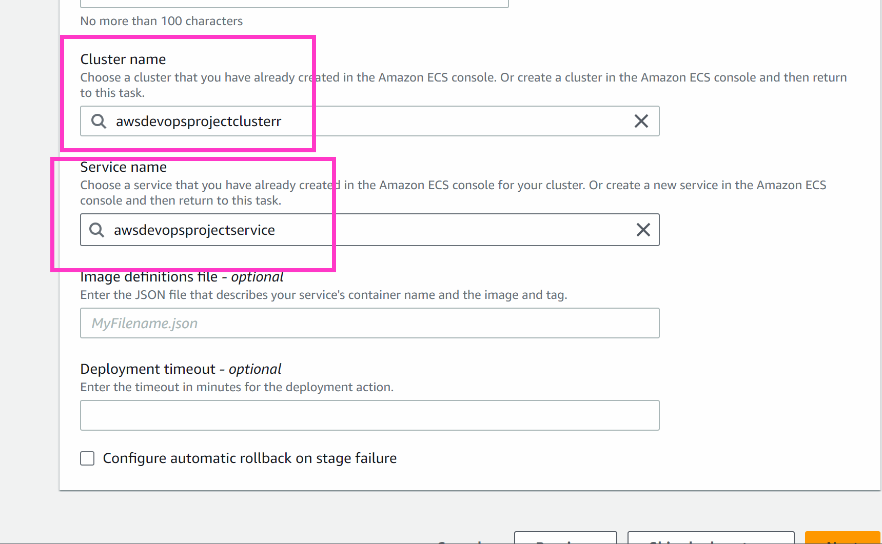

Next

Create the pipeline

Click on release change

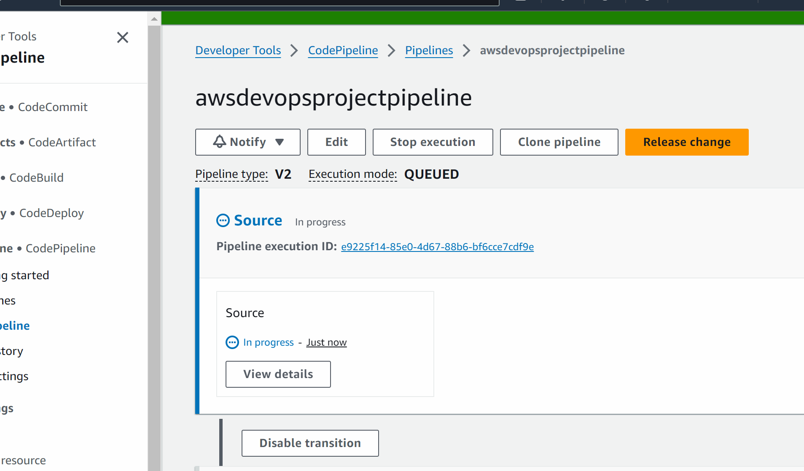

You will your pipeline would be executed successfully

######################

